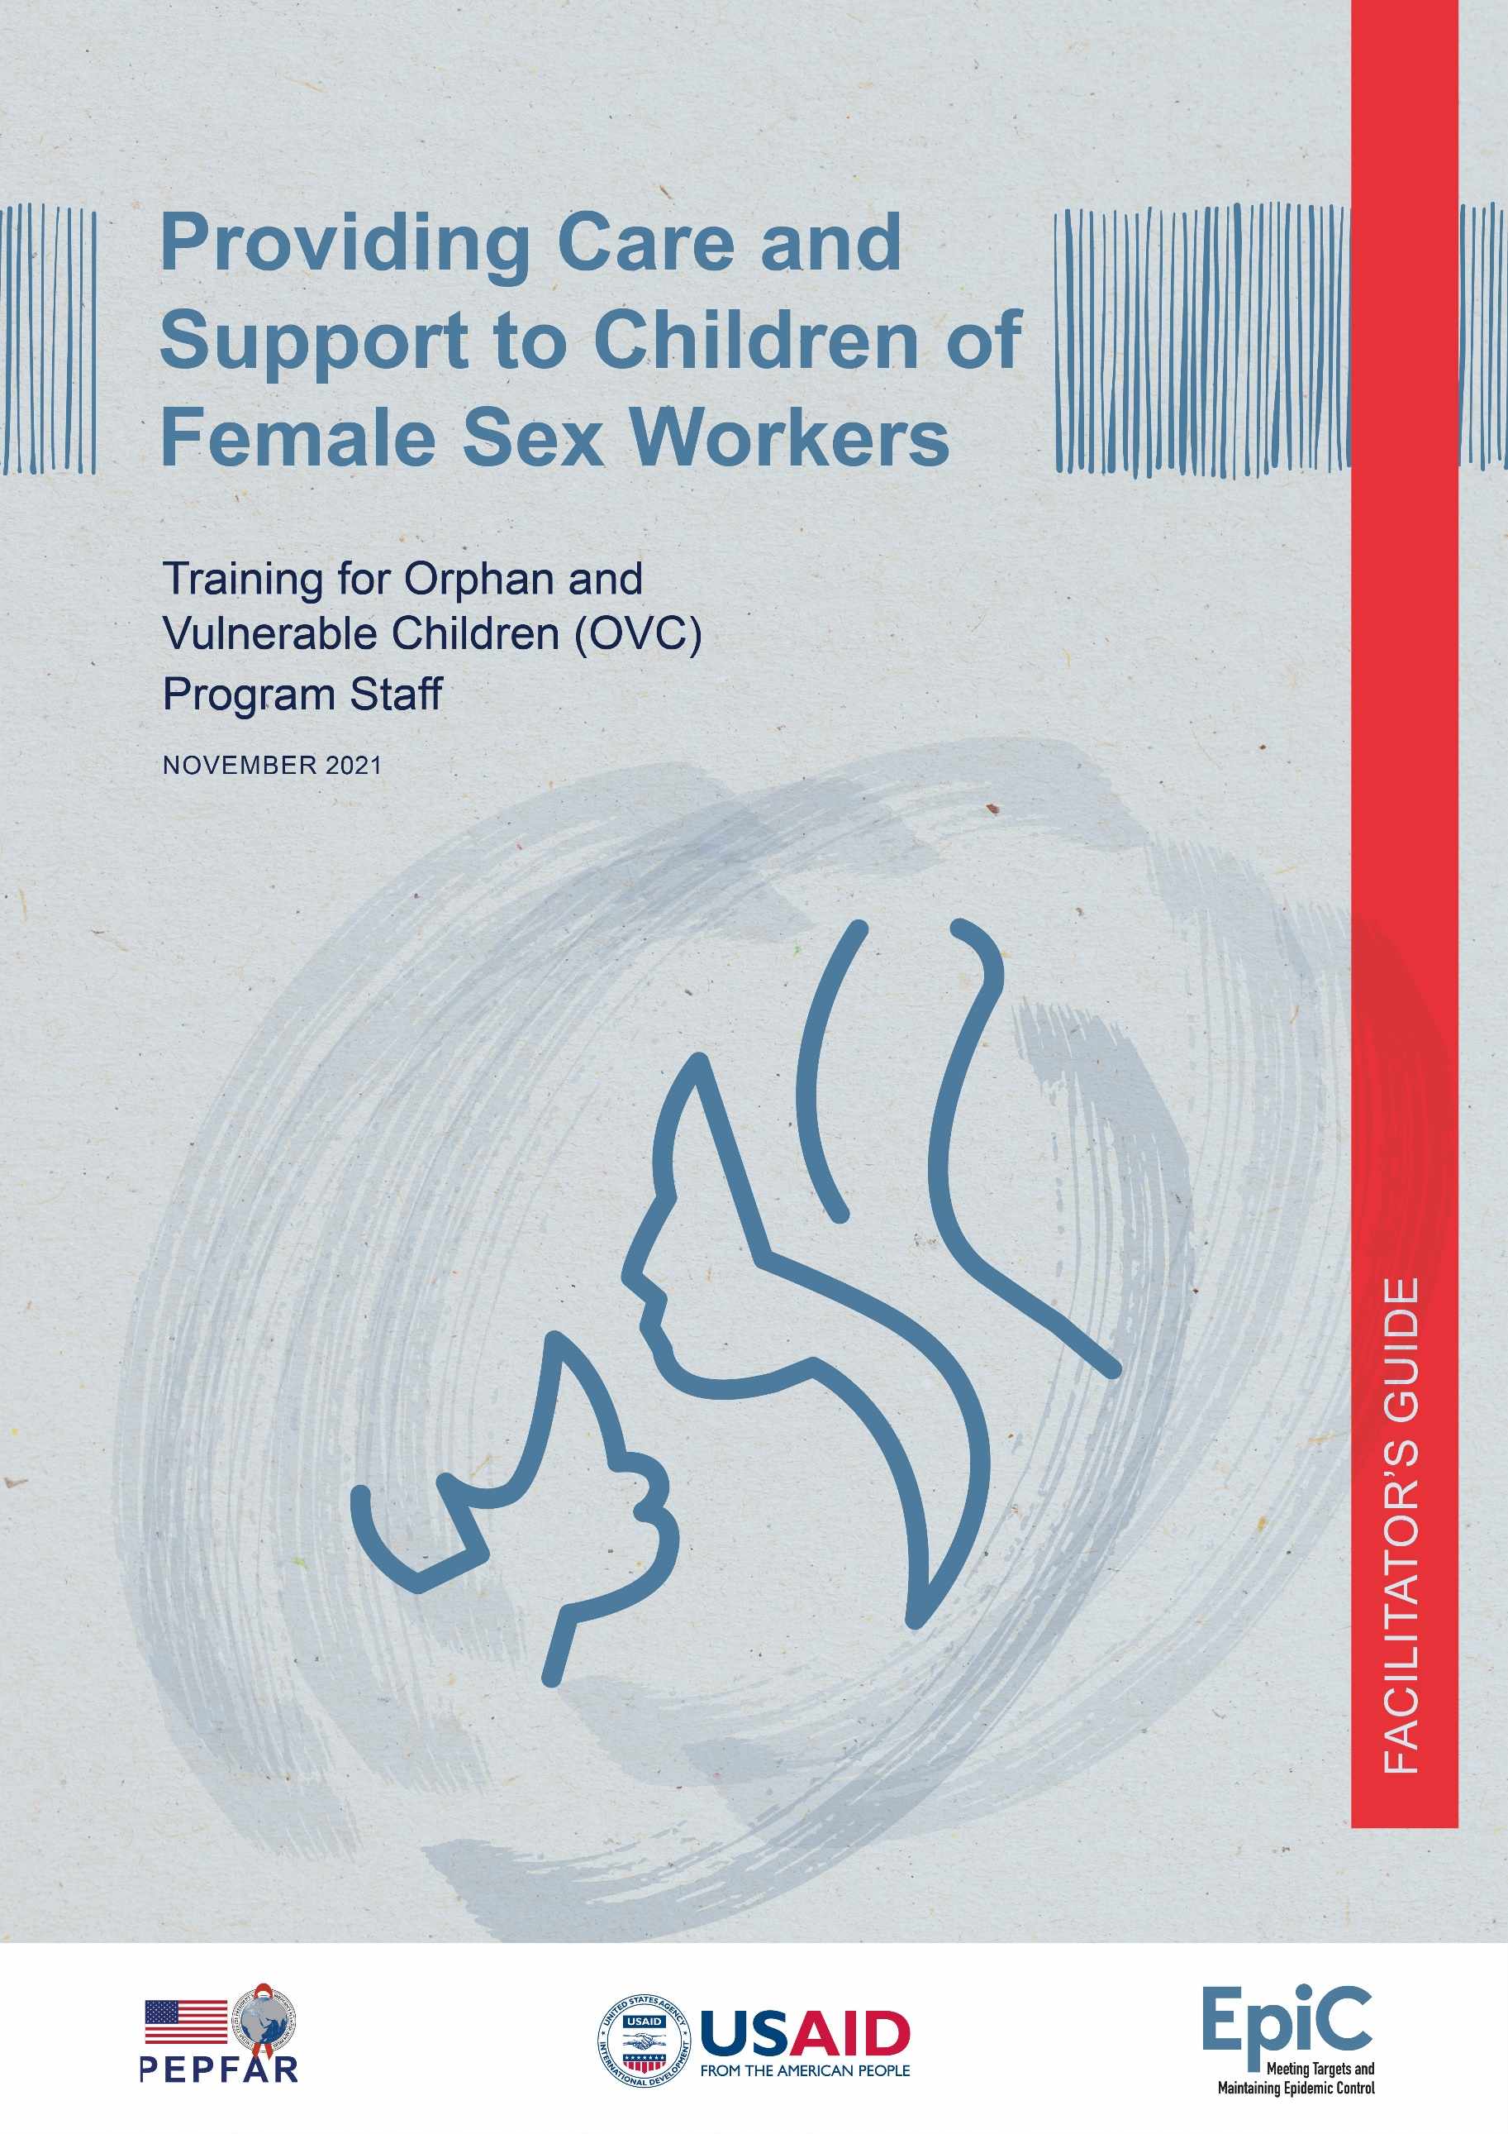

Acknowledgments
This training curriculum was developed by Tanya Medrano (Technical Advisor, FHI 360) and reviewed by Chris Akolo (Technical Director, HIV Programs, EpiC, FHI 360).
The curriculum was originally developed in 2020 for use in Malawi by the EpiC Malawi program. The original version was reviewed by EpiC Malawi staff Dunia Chiwala and David Chilongozi. This version is an adaptation of the original curriculum which can be used more broadly in countries throughout the African region.
We appreciate the review and constructive feedback for this adapted version of the curriculum provided by the following USAID reviewers:
- Sarah Dastur
- Meena Srivastava
- Nimasha Fernando
- Amy Aberra
- Sarah Yeiser
The guide was edited by Stevie Daniels with page layout by Lucy Harber and cover design by Jill Vitick using the illustration Motherly Love by Hat-Tech from the Noun Project.
Suggested Citation: Medrano T. Providing Care and Support to Children of Female Sex Workers: Training for Orphan and Vulnerable Children (OVC) Program Staff Facilitator’s Guide. Durham (NC): FHI 360; 2021.
This work was made possible by the generous support of the American people through the United States Agency for International Development (USAID) and the U.S. President’s Emergency Plan for AIDS Relief (PEPFAR). The contents are the responsibility of the EpiC project and do not necessarily reflect the views of USAID, PEPFAR, or the United States Government.

Meeting Targets and Maintaining Epidemic Control (EpiC) is a global cooperative agreement (7200AA19CA00002) led by FHI 360 with core partners Right to Care, Palladium International, Population Services International (PSI), and Gobee Group.

Table of Contents
Acronyms i
1. Introduction 1
1.1 Background 1
1.2 Intended Audience 1
1.3 Purpose and Objectives of the Training 1
2. Structure of the Training 2
3. Facilitator Guide 3
4. Implementation of the Training 4
5. Learning Strategies and Methods 4
6. Recommendations for Facilitators 5
6.1 Before the Training 5
6.2 During the Training 6
Training Opening Activities 7
Module One Learning Activities 14
Session 1.1: Exploring Our Beliefs and Attitudes Toward FSWs and Their Children 14
Session 1.2: Understanding Stigma Toward FSWs 18
Session 1.3: The Realities and Challenges of FSWs 26
Session 1.4: The Risks and Vulnerabilities of Children of FSWs 30
Module Two Learning Activities 34
Session 2.1: Addressing the Vulnerabilities and Needs of Children of FSWs 34
Session 2.2: Strategies for Finding and Reaching Children of FSWs with Services 40
Session 2.3: Principles and Personal Values for Delivering Safe and Acceptable
Services to Children of FSWs and their Families 48
Session 2.4: Action Planning to Provide Safe and Acceptable Services to Children of
FSWs and their Families 52
Training Closing Activities 56
Handouts 57
Handout 1: Stories of Sex Workers 58
Handout 2: Issues Faced by Sex Workers 59
Handout 3: Risks Experienced by Children of Female Sex Workers 60
Handout 4: Case Study of Collaboration between a KP and OVC Program in Malawi 62
Handout 5: Principles for Delivering Services to FSWs and Their Children 63
Handout 6: Personal Values that Will Help Me Deliver Safe and Acceptable Services to FSWs and their Children 65
Handout 7: Providing Care and Support for Children of FSWs
Organization/OVC Program Self-Assessment 66
Handout 8: Areas for Improvement in My Organization 67
Handout 9: Action Plan to Provide Safe and Acceptable Services for FSWs and Their Children in My Organization or OVC Program 68
Annexes 69
Annex 1: Sign-in Sheet 70
Annex 2: Sample Training Agenda 71
Annex 3: Pre- and Post-Training Questionnaire 73
Annex 4: Answer Key Pre- and Post-Training Questionnaire 75
Annex 5: Sample Training Energizers 77
Annex 6: End-of-Day Evaluation Form 78
Annex 7: Training Evaluation Form 79

Acronyms
AGYW Adolescent girls and young women
ART Antiretroviral therapy
ASRH Adolescent sexual and reproductive health
CALHIV Children and adolescents living with HIV
CFSWs Children of female sex workers
CPPP Child protection policy and procedure
EID Early infant diagnosis
EpiC Meeting Targets and Maintaining Epidemic Control
FP Family planning
FSWs Female sex workers
GBV Gender-based violence
HEI HIV-exposed infant
HIV Human immunodeficiency virus
HTS HIV testing services
KP Key population
MTCT Mother-to-child transmission
MUAC Mid upper-arm circumference
NACS Nutrition assessment, counseling, and support
OVC Orphans and other vulnerable children
PEPFAR U.S. President’s Emergency Plan for AIDS Relief
PMTCT Prevention of mother-to-child transmission
PrEP Pre-exposure prophylaxis
USAID United States Agency for International Development
VAC Violence against children
VL Viral load
WASH Water, sanitation, and hygiene

1. Introduction

1.1 Background
Children of female sex workers (CFSWs) are a highly vulnerable group of children due to their exposure to a combination of health, social, and economic risk factors. FHI 360’s experience working with this population across different African countries has shown that they often live in extreme poverty, experience food insecurity, have poor access to essential services, and are at increased risk of HIV infection, as well as physical, emotional, and sexual violence, and school dropout. Many of these risks are the result of stigma, discrimination, and social exclusion due to their mothers’ sex work.
Given their high level of vulnerability, CFSWs are a priority population in programs for orphans and vulnerable children (OVC) funded by the U.S. President’s Emergency Plan for AIDS Relief (PEPFAR). These programs are expected to reach CFSW with comprehensive care and support services using case management and a family-centered approach. However, because this is a marginalized population, OVC programs sometimes have challenges finding them and reaching them with services.
We acknowledge that sex workers can be males, and that they may also be caregivers of children. However, this training focuses specifically on the children of female sex workers (FSWs).
This training curriculum was originally developed and implemented in Malawi by FHI 360 and the Meeting Targets and Maintaining Epidemic Control (EpiC) project as part of a short-term USAID-funded project that aimed to improve access to services for CFSWs. The original curriculum was revised for implementation in other countries throughout the region.

1.2 Intended Audience
The training is primarily designed for implementers of PEPFAR-funded community-based OVC programs. However, it can also be used with only minor adaptations by other types of community-based programs that want to support the CFSW population. The training is specifically intended for program staff and community cadres responsible for designing and implementing service delivery activities for CFSWs and their families. In OVC programs, this may include OVC program coordinators or technical officers and community cadres such as case managers and case workers.

1.3 Purpose and Objectives of the Training
The overall purpose of the training is to strengthen the capacity of participants to provide services that meet the special needs of CFSWs (and their families) and are stigma-free and key population (KP) and child friendly. By the end of the training participants are expected to:
- Understand stigma and discrimination toward FSWs and how it impacts their children.
- Have a more empathetic attitude toward FSWs and their children.
- Understand the unique risks experienced by FSWs and their children, particularly the risk of HIV infection, and the health and social services they need.
- Have increased awareness of the challenges to finding and delivering services to CFSWs and the strategies they can use to overcome these challenges.
- Understand and adopt principles and values that make services safe and acceptable for FSWs and their children.
- Develop an action plan for their organizations to deliver services to CFSWs and their families that are safe, acceptable, and child- and KP-friendly.

2. Structure of the Training
This two-day training consists of eight learning sessions that are grouped into two modules. The learning sessions in the first module focus on helping participants understand the risks and challenges experienced by FSWs and their children and develop a more empathetic attitude toward this population. The learning sessions in the second module focus on helping participants understand the services that CFSWs and their families need, and the strategies for reaching this population with safe and acceptable services. The table below provides a snapshot of the training modules and learning sessions.
Module Description | Learning Sessions
Module 1: Understanding the Risks and Vulnerabilities of Children of FSWs  (4 hours and 5 minutes)  The activities in this module will take participants through a journey of reflection and learning that will help them understand better the risks children of FSWs are exposed to and the root causes of those risks, particularly stigma and discrimination. | 1.1 Exploring our beliefs and attitudes toward FSWs and their children (40 minutes)  1.2 Understanding stigma toward FSWs (1 hour and 30 minutes)  1.3 The realities and challenges of FSWs (50 minutes)  1.4 The risks and vulnerabilities of children of FSWs (1 hour)
Module 2: Delivering Safe and Acceptable Services to Children of FSWs and Their Families (6 hours and 15 minutes)  The activities in this module will help participants understand the services that children of FSWs and their families need, the challenges in delivering services to this population, and strategies that can be used to overcome these challenges. It will also help participants understand the principles and values that should guide service delivery to this population to ensure services are safe and acceptable for them. | 2.1 Addressing the vulnerabilities and needs of children of FSWs (1hour and 25 minutes)  2.2 Strategies for finding and reaching children of FSWs with services (1 hour and 55 minutes)  2.3 Principles and personal values for delivering safe and acceptable services to children of FSWs and their families (1 hour and 10 minutes)  2.4 Action planning to provide safe and acceptable services to children of FSWs and their families (1 hour and 25 minutes)

3. Facilitator Guide
This guide contains all the information needed to carry out the learning activities that are part of the training, including a step-by-step description of how to implement each learning activity and the slides and handouts needed for each activity.
The description of each learning activity includes the following information and icons:
Time: The estimated time needed to complete the activity. Within the activity steps, times are also suggested for various parts, for example, 15 minutes for small group work, 10 minutes for a discussion, etc. Times are approximate, but facilitators should try to stay more or less within the suggested times. If this is not possible, facilitators should adjust the training accordingly.
Learning Objectives: A list of the knowledge and skills that participants will gain during the unit.
Learning Methods: The teaching method(s) used during the activity, for example, small group activity or presentation.
Materials: A list of the materials needed to complete the activity. Facilitators must review the list and gather all materials before the day of the training.
Prepare: Things the facilitator must do to prepare for the activity.
Introduction: Explains the key messages the facilitator must share with participants at the beginning of a session.
Learning Activity: Detailed steps that guide the facilitator through each learning activity.
Facilitation Notes and Tips: Recommendations for facilitators to consider during the implementation of specific steps in a learning activity. These notes and tips are always included in a box.
Tips for Virtual Implementation: Recommendations on how to adapt the learning activity for virtual implementation or delivery.
Key Messages: Key points facilitators need to summarize at the end of a learning session.

4. Implementation of the Training
Because learning activities in this training curriculum build successively on previous material, they should be implemented in the order provided. Ideally, the training should be delivered during a two-day workshop. However, country programs could make adjustments based on their needs. For instance, if necessary, the training could be split into two training workshops, each focusing on a different module.
The facilitators or trainers who deliver this training should be individuals with technical expertise in programming for vulnerable children and experience facilitating learning activities using participatory methodologies.
To optimize opportunities for participation and learning, the number of participants in the training should be limited to 20–25. Furthermore, the training and associated tools should be translated into the local language. Country programs should feel free to adjust terms, phrases, and concepts to match local vernacular and context.

5. Learning Strategies and Methods
This training was designed based on adult learning principles. The learning activities build on participants’ previous knowledge and experiences and are highly participatory. Participants are actively involved in the learning process through methods such as reflection, discussion, and group work. The combination of methods used in the training work together to enhance participants’ learning and make activities more dynamic and engaging. Following is an overview of these methods and how they are used:
Group Discussions: Group discussions are used to help participants think critically, consider multiple viewpoints, and develop knowledge about a particular subject. They are held in large or small groups.
- In large group discussions the dialogue is between the facilitator and all the participants in the training. The facilitator uses previously prepared questions to promote the discussion and encourage as many participants as possible to participate. The facilitator should make eye contact and move around the room to maintain the attention of all participants and keep the discussion on target. She/he must also show respect for all comments, regardless of whether she/he agrees with them or not and develop helpful responses to incorrect answers or comments.
- In small group discussions the dialogue is among a small group of participants (usually 3–6 per group), who respond to questions the facilitator has prepared ahead of time. The facilitator gives clear instructions for the discussion before dividing participants into small groups. As small groups are discussing, the facilitator circulates among them to make sure all group members are participating and to help groups keep the discussion on target.

Work in Small Groups: Small groups of participants work together during a certain period of time to jointly complete a task or assignment that enhances their learning of new knowledge or skills. Similar to the small group discussions, the facilitator gives clear instructions for the group work before dividing participants into groups. As groups are working, the facilitator circulates among them to make sure all group members are engaged and to offer any information or support the groups may need.
Brainstorming: The facilitator asks a question or poses a problem and asks participants to give as many ideas as they can in response. Brainstorming is used to generate a lot of new ideas quickly.
Case Studies: A case study is a brief story or scenario depicting a realistic situation for participants to discuss and analyze. Case studies give participants the opportunity to use newly acquired knowledge to discuss or analyze problems or situations related to the training topic.
Presentation: A traditional method in which the facilitator presents information to the group using slides or a flipchart. Presentations are used to introduce new information or to review information. They are short and accompanied with discussion.

6. Recommendations for Facilitators
Facilitators are encouraged to follow these recommendations for an effective training:

6.1 Before the Training
- Familiarize yourself with the learning activities. Read the facilitator’s guide thoroughly to acquaint yourself well with each learning activity. This way you will not have to constantly refer to the guide during the training. You need to spend as much time as possible talking and listening to participants, not reading the guide.
- Designate a co-facilitator or training assistant. A co-facilitator helps with some of the learning activities. If you have a co-facilitator, meet with him/her ahead of time to decide who will be responsible for what learning activities and divide the work accordingly. If having a co-facilitator is not possible, then at least try to have a training assistant. Having an assistant can make the training run more smoothly and save time. This person can help you set up the room and organize materials before the training, distribute materials and resources during the training, take care of logistics for breaks and lunch, and help you keep track of time. This person does not need to have facilitation skills, but good organization, coordination, and time management skills. If it is not feasible to have an assistant, ask participant(s) to volunteer and provide support with tasks that won’t interrupt their learning process (e.g., distribution of materials).

- Prepare the materials for each learning activity. Review the “Materials/Resources” and “Prepare” sections in each learning activity to identify what you will need. Having all the necessary materials and resources at hand will make the training run more smoothly and prevent unnecessary stress and time delays.
- Prepare several energizers. Prepare several brief, fun energizers to increase participants’ attention and energy levels throughout the training as needed. Annex 5 provides a list of sample energizers.
- Visit the venue where the training will take place. Get acquainted with the space where the training will take place so you can plan how to organize it. Make sure there is proper light and ventilation, and that the room is big enough to allow participants to break out into small groups. Also make sure that all necessary resources (chairs, tables, etc.) are available.
- Set up the room to facilitate interaction. Organize the room in a way that allows you to see all participants, and all participants to see each other. This will facilitate interaction. A formal classroom-like setting is not recommended. Rather, try to organize chairs in semicircles.

6.2 During the Training
- Create a safe and relaxed learning atmosphere for participants. A relaxed person learns more easily than one who is fearful, stressed, or embarrassed. During the training you must always show a warm, respectful, and supportive attitude toward participants to create a relaxed learning atmosphere. The ground/group rules should also contribute to this atmosphere by ensuring that everyone’s opinions are heard and respected.
- Ensure equity in participation. Give all participants equal opportunity to participate and express their ideas and opinions. When you ask questions, allow different participants to answer each time, and do not let any single person monopolize discussions.
- Monitor and support participants during group work. When participants are working in small groups, walk around the room and provide encouragement, input, and support as needed.

Training Opening Activities
Time: 1 hour and 30 minutes
Objectives:
Welcome participants
Allow participants to get to know one another as well as the facilitator(s) of the training
Identify participants’ expectations
Introduce participants to the training’s learning objectives, activities, and methods
Establish the group rules
Assess participants’ pre-training knowledge on the topics of the training
Familiarize participants with the U.S. Government’s Anti-Prostitution Pledge
Materials:
Participant sign-in sheet
Name tags
Training agenda
Pre-training and post-training questionnaire (Annex 3)
Answer key pre-training and post-training questionnaire (Annex 4)
Slides #2–9
Sticky notes
Pens
Sheets of paper in different colors (red, yellow, orange, green, and purple)
Flip chart
Prepare:
Make a copy of the training agenda and the pre- and post-training questionnaire for each participant
Cut the colored sheets of paper into small pieces and put them in a bag. Make sure there is one piece of paper for each participant. Also, ensure you have a similar number of pieces of paper in each color.

Activity 1: Welcome and introductions (25 minutes)
- Allow a senior representative from the organization/program sponsoring the training and/or a local government official to formally open the training. The main purpose is to describe the importance of the training and to inspire and motivate participants to improve service delivery for CFSWs (5 minutes).
- Welcome participants and introduce yourself and your co-facilitator or training assistant.
- Ask participants to introduce themselves. Provide instructions for the introductions using slide #2 (20 minutes).
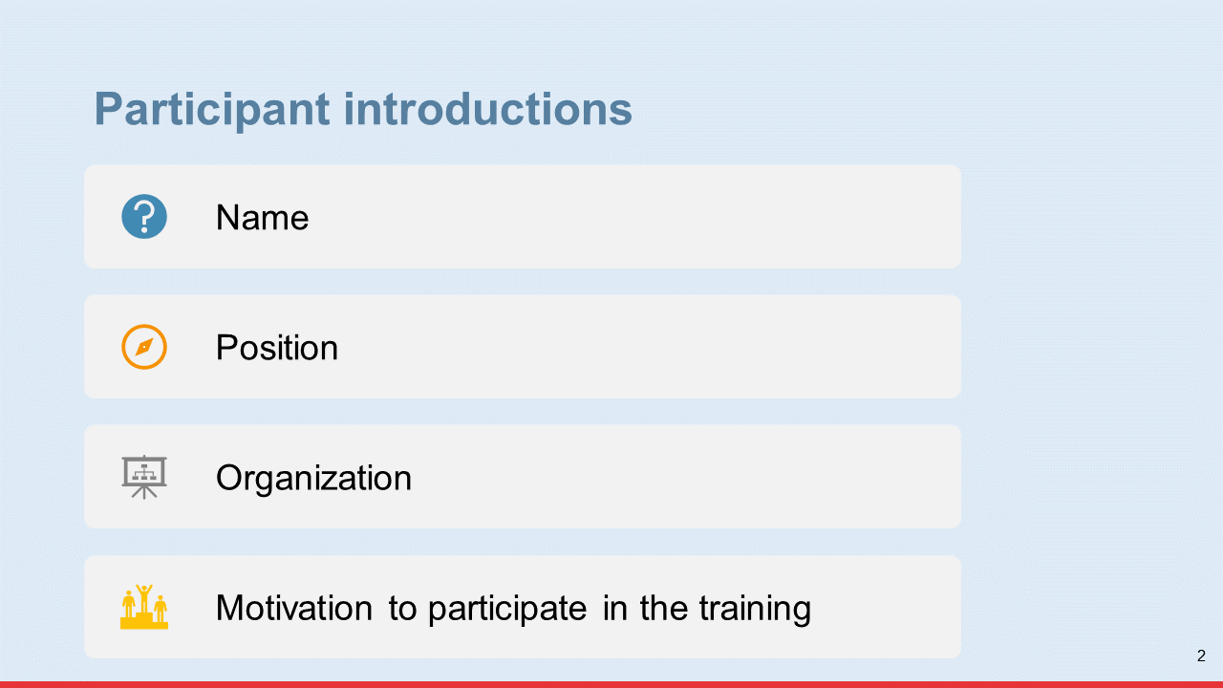
Activity 2: Participant expectations and learning objectives (10 minutes)
- Explain that it is important for you to understand what participants expect to learn during the training so you can make any clarifications that are necessary. The next activity will help identify these expectations.
- Provide instructions for the expectations exercise using slide #3 and distribute sticky notes to participants.
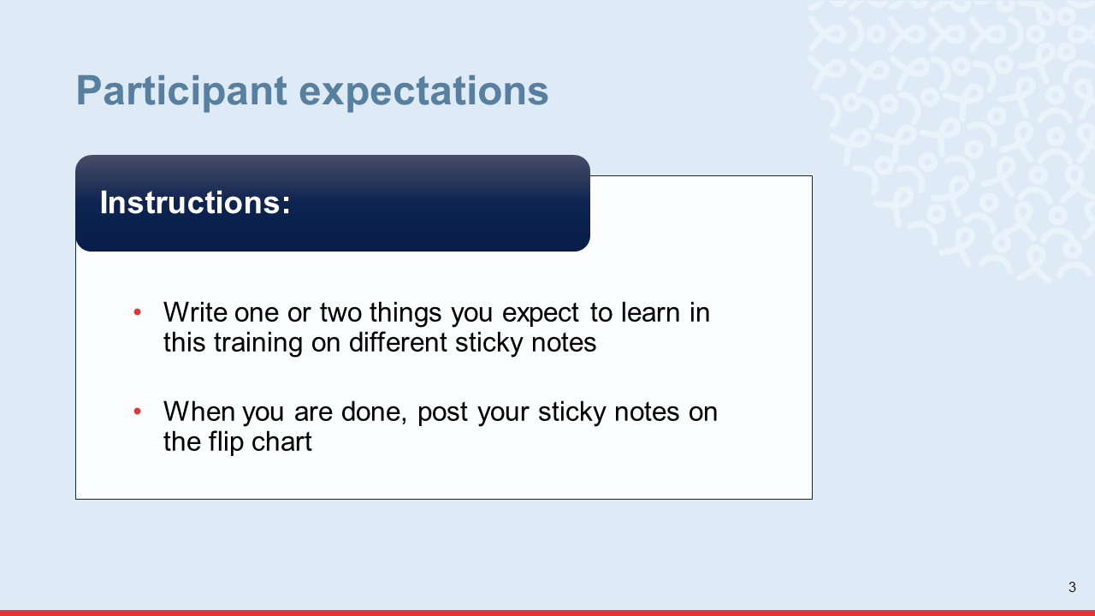
- As participants post their sticky notes on the flip chart, group those that are the same or similar.
- Discuss the training’s learning objectives using slide #4. As you discuss the objectives, explain which participant expectations (written on the sticky notes) will be met by the training and which will not, and why.
- Answer any questions participants may have about the objectives.
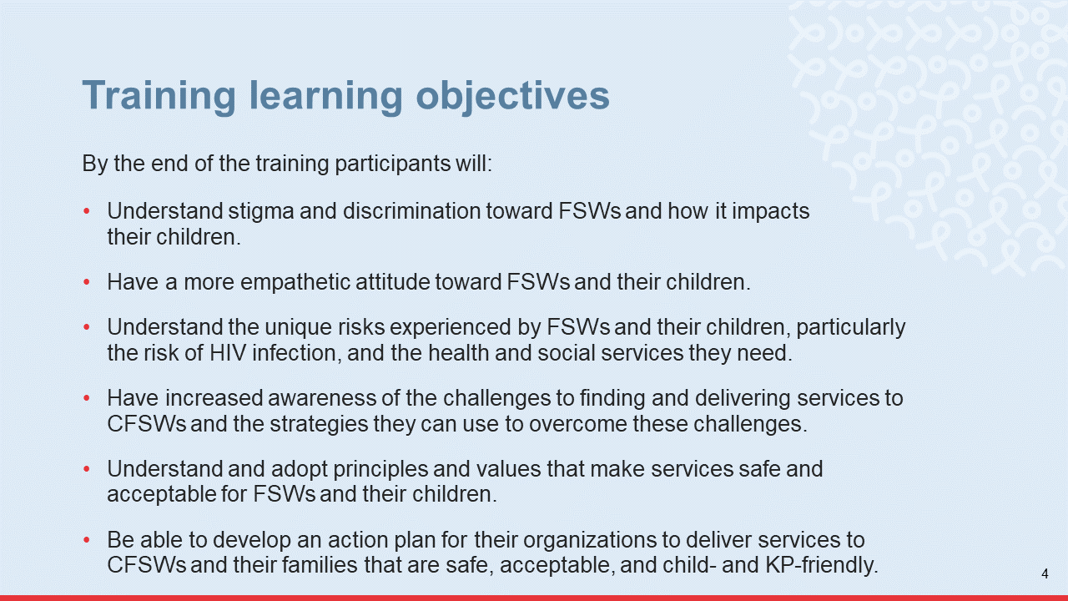
Activity 3: Learning activities and methods and training agenda (10 minutes)
- Explain the topics and learning activities that will be covered by the training using slide #5. Answer any questions participants may have about the learning activities.
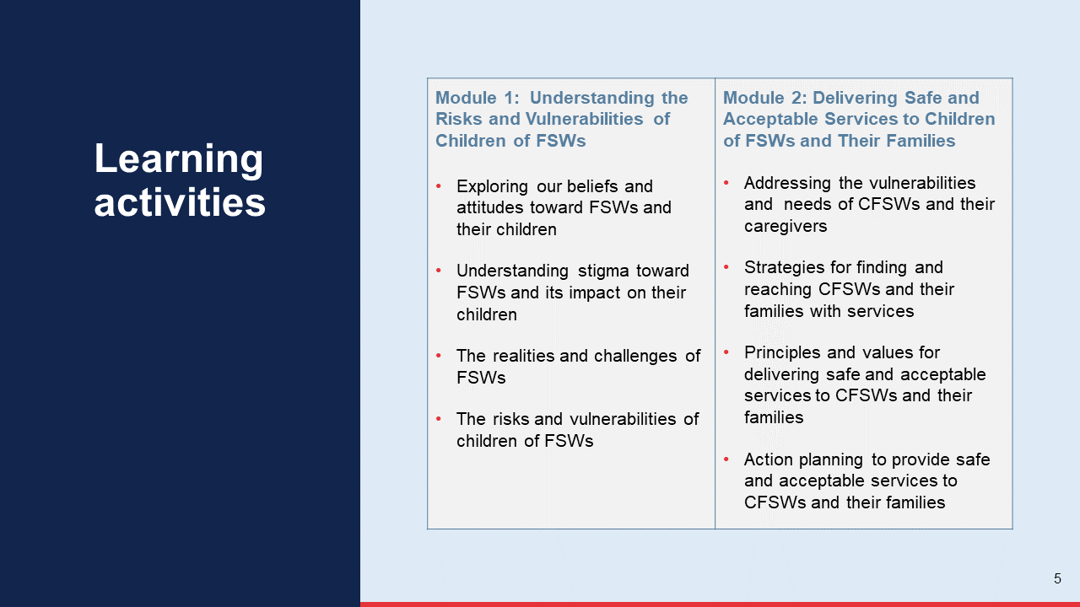
- Explain that the training has been designed based on adult learning principles, so the learning activities are:
Participatory and interactive: They will not simply receive information. They will be actively involved in the learning process through participatory learning methods.
Designed to build on their previous knowledge and experiences: They already have a wealth of valuable knowledge and experiences. The training will aim to draw and build upon their existing knowledge and experience through reflection and discussions.
Practical. They will put into practice what they learn through hands-on exercises.
- Share some of the learning methods that will be used (slide #6).
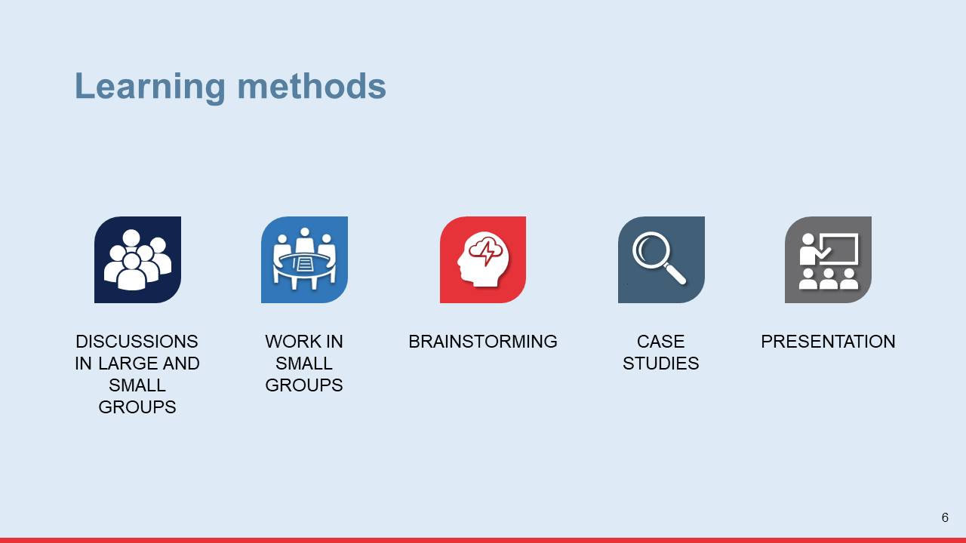
- Distribute and review the training agenda. Answer any questions participants may have about it (slide #7). Annex 2 has a sample training agenda you can adapt.
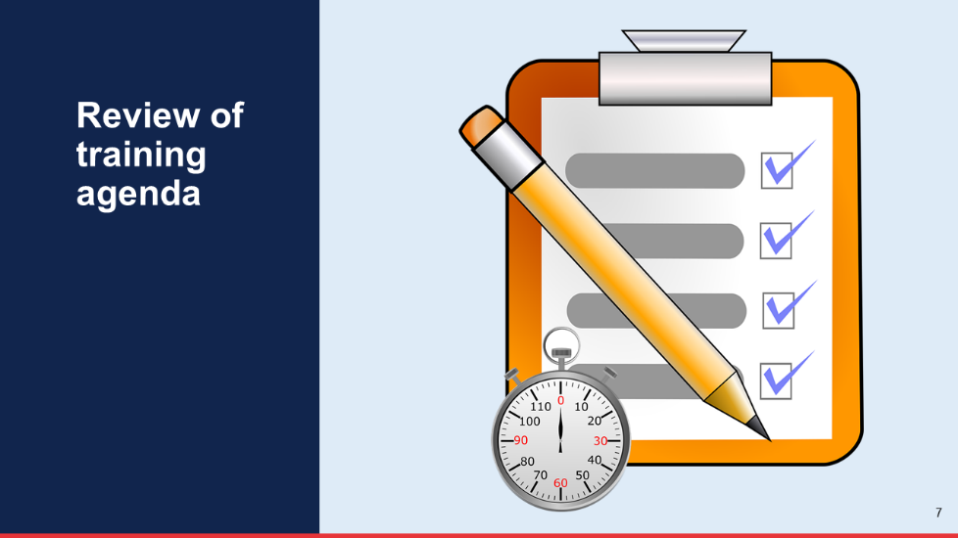
- Provide housekeeping information (e.g., where breaks and lunch will be taken, location of restrooms, etc.).

Activity 4: Group rules (10 minutes)
- Explain to participants that establishing group rules is very important for the training. Group rules are expectations or standards of behaviors for participants and facilitator(s) that will help the training go smoothly (slide #8).
- Ask participants to brainstorm the rules they would like the group to follow and take note on a flip chart page with the title “Group Rules”. Make sure everyone agrees on each rule before you write it on the flip chart page.
- When the list of group rules is finalized, make sure the following are included. If not, suggest them to the group:
Group Rules
Arrive on time
Participate actively
Raise your hand when you want to speak
Ask when something is not understood
Share your experiences and expertise with the group
Respect others’ ideas and opinions
Provide constructive feedback, not criticism
Keep others’ information confidential
Switch off, or avoid using cell phones and laptops during the training
- Post the flip chart page with the group rules on a wall where everyone can see them and keep it there throughout the training.
- Explain that the group should try to stick to the rules, and that new rules can be added during the training, if necessary.

Activity 5: Pre-training questionnaire (10 minutes)
Facilitation Notes and Tips
Remember, facilitators set the tone. Respect the ground rules yourself and lead by example. Make sure that you listen to participants and are sensitive, open, and respectful when answering questions or responding to differences of opinion. If staying on time is a rule, then finish your sessions promptly. However, if group sessions are taking more time than planned and risk running over, ask participants if they would prefer to continue or, to rearrange, the sessions
- Distribute the pre- and post-training questionnaire (Annex 3) to each participant. Explain that this questionnaire aims to assess how much they already know about the topics that will be covered in the training. The questionnaire is anonymous, so they should not write their name on it. Instead, they will use the last four digits of their cell phone number, as indicated in the questionnaire.
- Give participants 10 minutes to complete the questionnaire.
- Use the answer key (Annex 4) to score the questionnaires.
Activity 6: Icebreaker (15 minutes)
This icebreaker will help participants get to know each other in a fun way and establish a safe and more relaxed learning environment for the group.
- Explain to participants they will now do a quick icebreaker that will help them get to know each other better.
- Provide instructions for the icebreaker using slide #9.
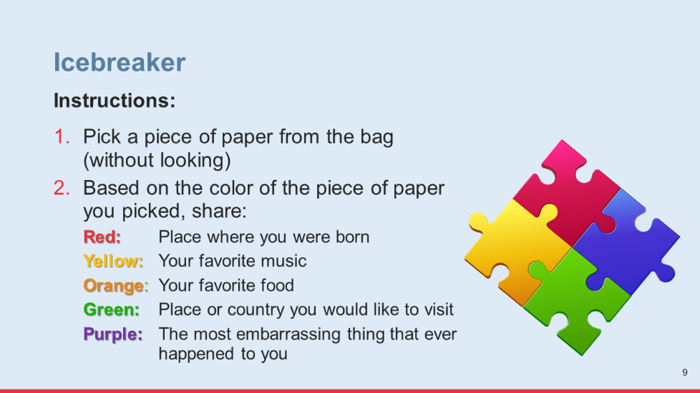
- Thank participants for sharing their information in the icebreaker.

Activity 7: The USG’s anti-prostitution pledge (10 minutes)
- Explain to participants that the U.S. government (USG) has an anti-prostitution pledge. It is important for organizations that implement USG-funded programs for populations involved in sex work, such as FSWs, to become familiar with this pledge.
- Provide information on the USG’s anti-prostitution pledge using slide #10.
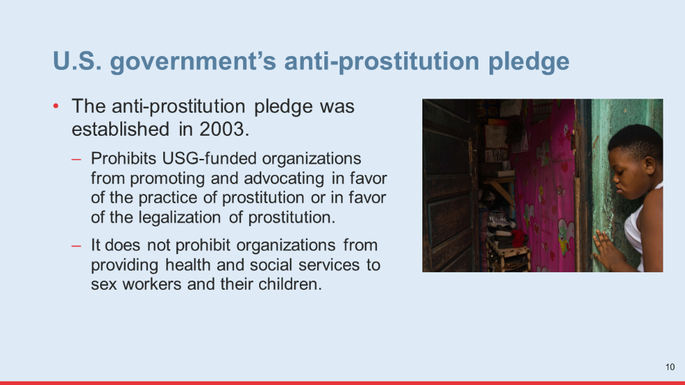
- Answer any questions participants may have about the USG’s anti-prostitution pledge.

Module One Learning Activities

Session 1.1: Exploring Our Beliefs and Attitudes Toward FSWs and Their Children
Time: 40 minutes
Learning Objectives:
After completing this session, participants will be able to:
Acknowledge their personal beliefs and attitudes toward FSWs and their children.
Learning Methods: Group exercise, group discussion
Materials:
Large pieces of paper (e.g., flip chart paper) to make signs
Markers
Tape
Slide #11
Prepare:
Review the list of statements in the Value Statements box further below. Select the statements that are best suited to your local context for the “Vote with your feet” exercise. Make sure to select statements that relate to both FSWs, and children of FSW.
Make three large signs with the words “Agree,” “Disagree,” and “Unsure.” Each sign should be taped to a different wall in the training room just before the “Vote with your feet” exercise.
Introduction:
Introduce this learning activity by explaining to participants that it will help them identify and understand their own personal beliefs and attitudes toward FSWs and their children.
Learning Activity 1: Vote with your feet exercise (40 minutes)
- Ask all participants to stand in the center of the room for the next exercise. Explain they will do an exercise called “Vote with your feet.” Provide instructions using slide #12 (30 minutes).
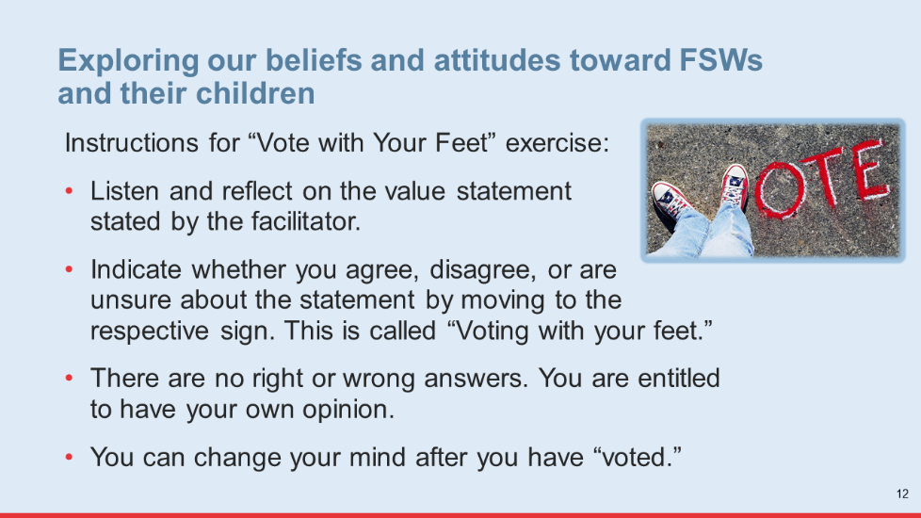
Tip for Virtual Implementation
Ask training participants to “vote” on the value statements by typing “agree,” “disagree,” or “unsure” in the chat box
- Follow these facilitator instructions for this exercise:
Read the first statement in the box below. Allow participants a minute to reflect on the statement and decide how to “vote.” Repeat the statement if necessary.
After all participants have “voted” by moving to a specific sign (agree, disagree, unsure), ask one or two in each group to explain their vote or opinion.
Allow people in each group to change their opinion and switch groups if they hear something that makes them change their mind.
Repeat this process with each statement until you have read all of them.

VALUE STATEMENTS
- Children of sex workers are a bad influence for other children, so they should not go to school or play with other children.
- Children of sex workers need love and protection. They are just like any other children.
- Girls whose mothers are FSWs receive a bad example, so they end up also being FSWs.
- Children of FSWs have the potential to live healthy, productive, and successful lives if offered helpful services, supports, and opportunities.
- Sex workers are human beings and deserve to be treated with dignity and respect.
- Sex workers deserve to get HIV because of their immoral behavior.
- Sex workers are like other women. They can be good mothers, sisters, and aunts.
- Sex workers sell sex for money because they are too lazy to work. They could easily get other jobs.
- Sex workers often neglect their children, leaving them unsupervised while they are working, which is unresponsible.
- Sex workers are sex maniacs—they love to have sex with anyone.

Facilitation Notes and Tips
If you think participants would feel uncomfortable responding to the statements, adapt the instructions. For instance, you can tell them that their response can represent the opinion of most people in their community (rather than their own personal opinion).
Remind participants about the ground rule of respecting others’ views or opinions, even when they don’t agree with them.
Remain neutral during this exercise. Do not influence participants’ responses to the statements either verbally or with your body language.
- After participants have “voted” on all of the statements, thank everyone for their honesty and willingness to share their opinions. Acknowledge those who were willing to change their position after reflecting and listening to others’ opinions. Ask participants to return to their seats.
- Promote reflection and discussion on the previous exercise by asking participants the following questions (10 minutes):

Questions for group discussion:
How did you feel during this exercise? Was it difficult for you to “vote” or express your opinion? If so, why?
Why do you think there were differences in opinions on the statements among people in this group?
Do you think it is important for people who provide services to FSWs and their children to explore their personal beliefs and attitudes toward this population? Why?
How can the beliefs and attitudes of service providers toward certain populations affect the services they provide to them?

Tip for Virtual Implementation
For a virtual discussion, ask training participants to click on the “raise your hand” icon when they want to respond to a question. Make sure as many participants as possible participate in the discussion.
Key Messages:
End this session with the following key messages:
- We are influenced by the social, cultural, and religious norms and values in the communities and homes where we grow up and live. These norms and values shape our beliefs and attitudes.
- We often have negative beliefs and attitudes toward sex workers because it is what we have learned. We may have been brought up to believe that FSWs are bad and immoral people.
- As providers of services to FSWs and their children, it is important that we acknowledge any negative values, beliefs, and attitudes we may have toward FSWs and work to change them to avoid displaying stigmatizing behaviors toward them.

Session 1.2: Understanding Stigma Toward FSWs
Time: 1 hour and 30 minutes
Learning Objectives:
After completing this session, participants will be able to:
Define stigma and describe how a person becomes stigmatized
Describe the consequences of stigma
Demonstrate a more empathetic attitude toward FSWs based on their own experiences of being stigmatized and discriminated against
Learning Methods:
Presentation
Discussion in small groups
Personal reflection
Materials:
Slides #13–22
Prepare:
Not required
Introduction:
Introduce this session by explaining to participants that the next learning activities will help them understand key concepts related to stigma, the root causes of stigma toward FSWs, and the impact of stigma on FSWs’ children.
Learning Activity 1: Key concepts related to stigma and discrimination (25 minutes)
- Explain to participants that since they will work with FSWs and their children, who are members of a highly stigmatized population, it is important that they understand well the concepts of stigma and discrimination, how people become stigmatized, the different types of stigma, and the impact stigma and discrimination have on people who experience it.
- Review key concepts related to stigma and discrimination using slides #13-18 (10 minutes).
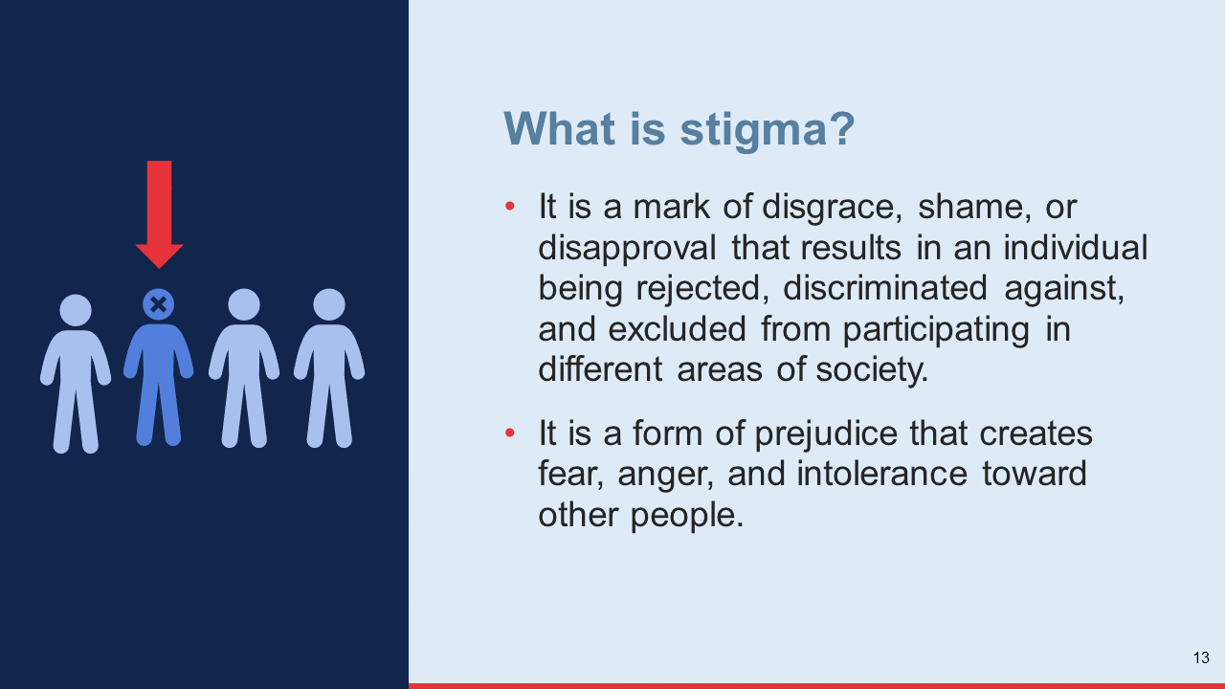

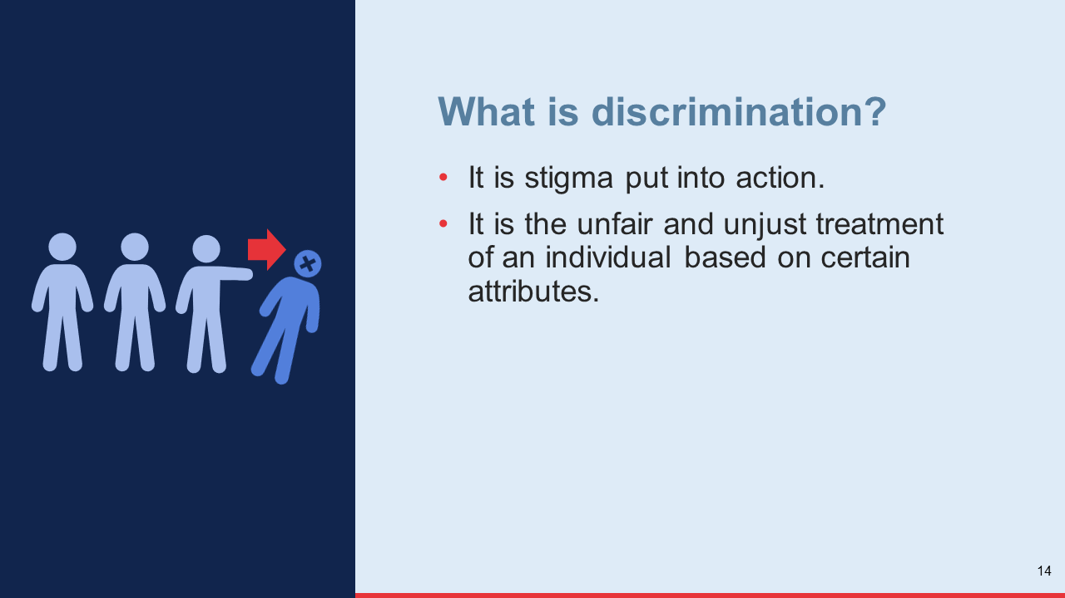

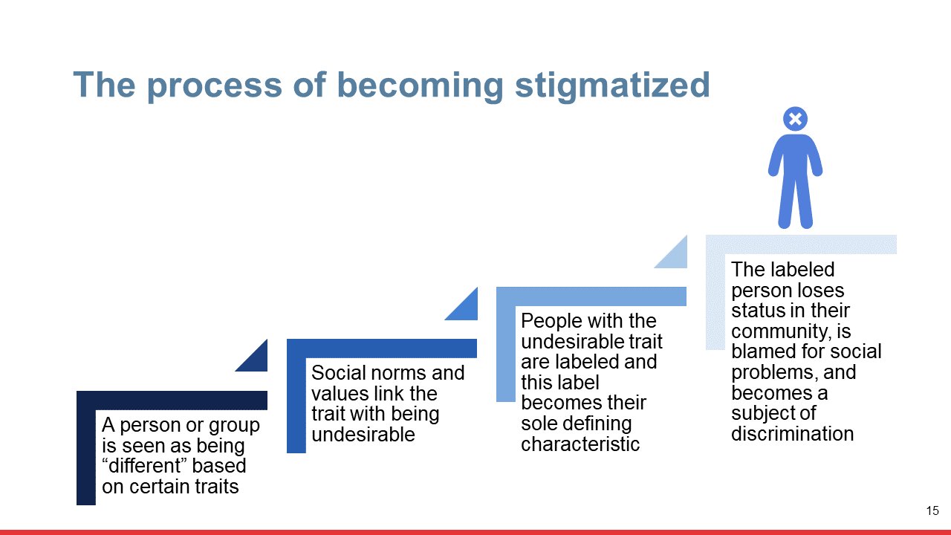
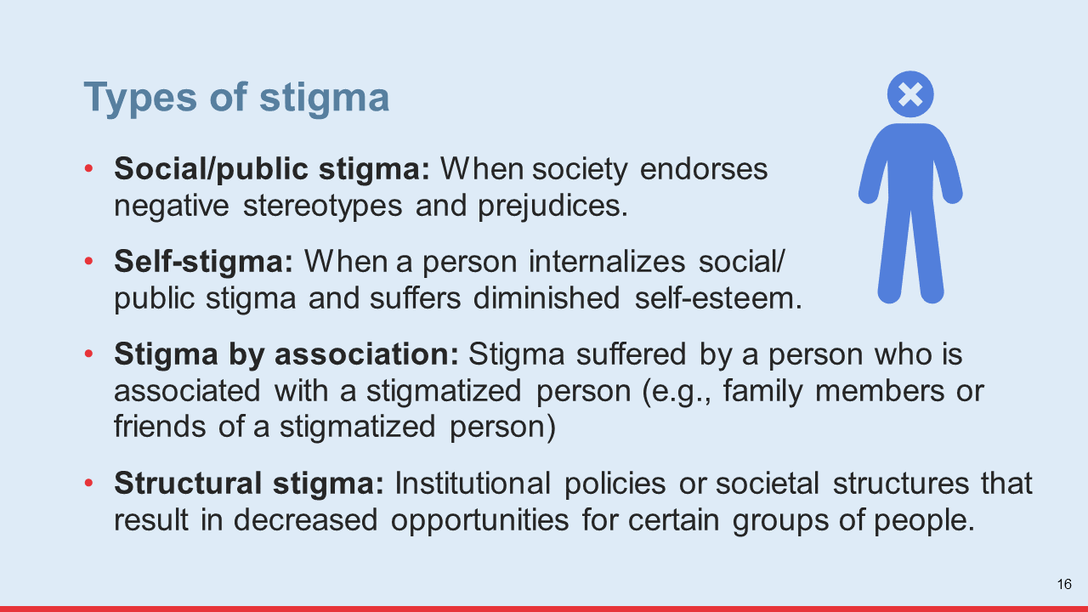

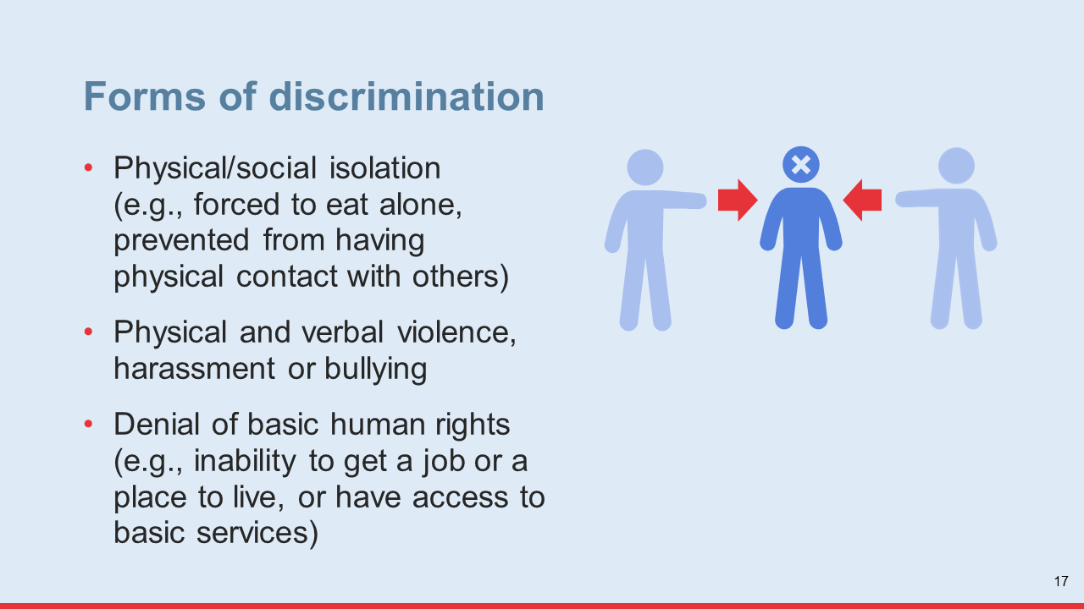

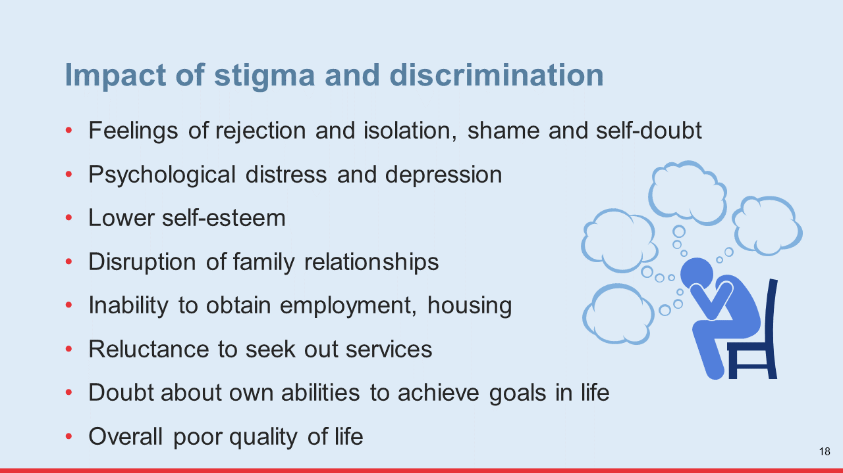
- Ask participants if they have any questions on the information you have just reviewed and respond to those questions.

- Promote a brief group discussion about different types of stigma and forms of discrimination participants have seen in the local context by asking the questions below. During the discussion, correct any misconceptions participants may still have about stigma and discrimination (15 minutes):
Which types of stigma have you seen in your community or in this country?
Who was the person stigmatized and why do you think they were stigmatized?
What forms of discrimination did this person experience? How was this person affected by this experience of discrimination?
Tip for Virtual Implementation
For a virtual discussion, ask training participants to click on the “raise your hand” icon when they want to respond to a question. Make sure as many participants as possible participate in the discussion.
- Thank participants for sharing their experiences and move on to the next learning activity.
Learning Activity 2: The impact of stigma on children of FSWs (30 minutes)
- Explain to participants that they will now have discussions in small groups. Share the questions for discussion using slide #19 and then ask them to break into small groups of 4–5 participants (15 minutes).
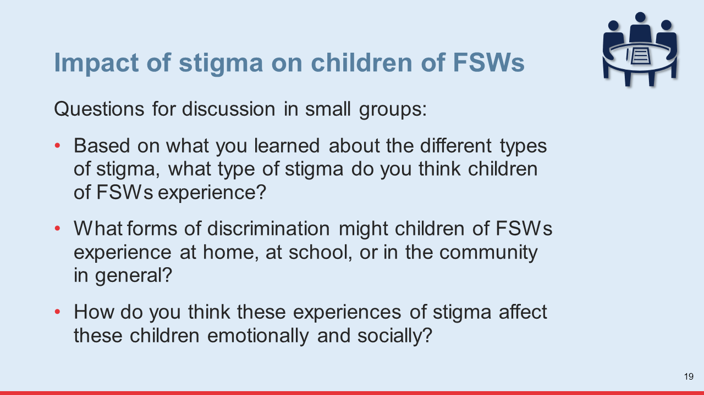

Tip for Virtual Implementation
For a virtual discussion in small groups, use a “breakout room” function which allows you to place participants in small groups and to assign time for the discussion. Once you have done this, participants will be automatically transferred to their breakout room, and when the time for the discussion is up, they will automatically be brought back to the large group.
- Once the time for group discussion is up, give each group three minutes to present the results of their discussion. After the first group presents, ask subsequent groups to only present things that have not been mentioned by the previous groups (15 minutes).
- Thank the groups for their contributions and ask them to go back to their seats.
Learning Activity 3: Our own experiences with stigma and discrimination (25 minutes)
- Explain to participants that everyone has been mistreated or rejected for being different at some point in their lives. They will now think about times in which they, personally, had this experience.
- Provide the instructions for this reflection exercise using slide #20 (5 minutes).
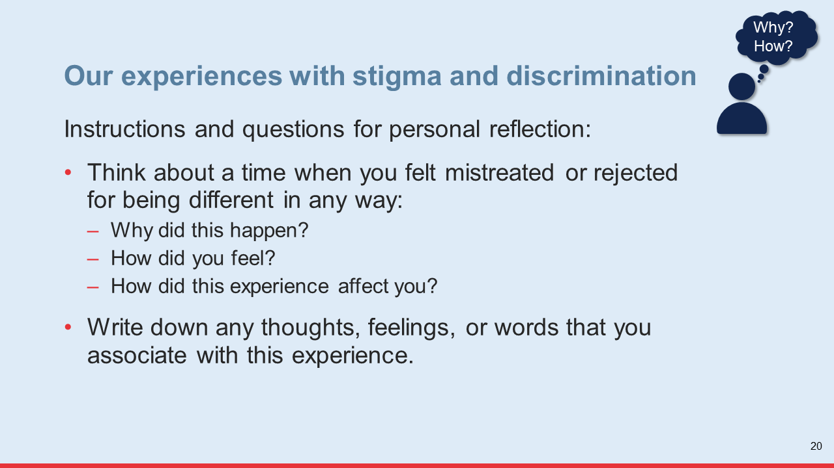
- After the time for reflection is up, invite a few participants to share their experience with the group, but only if they feel comfortable doing so (10 minutes).
Facilitation Notes and Tips
Help participants overcome any discomfort with sharing their own personal experiences with stigma and discrimination by emphasizing that all sharing is voluntary and that all information shared will be kept confidential and not repeated outside the training room.
- Thank participants for sharing their experiences. Express solidarity toward all those who’ve experienced rejection and mistreatment (regardless of whether they shared their experience with the group or not).
Facilitation Notes and Tips
This activity may remind participants of painful experiences. Because some people are more sensitive than others, be attentive to any participants in need of emotional support after this activity and make sure they receive that support.
- Ask participants to go back to their seats.
- Help participants associate their experience of being mistreated/rejected with the experiences of FSWs and their children by asking the following questions (10 minutes):
How does your own experience of being mistreated and rejected help you understand how a FSW or child of a FSW might feel when they are mistreated and rejected in their families and communities?
Do you feel more empathy toward FSWs and their children now? Why or why not?
How do you think empathy toward FSWs and their children can help you in your work with this population?
Tip for Virtual Implementation
For a virtual discussion, ask training participants to click on the “raise your hand” icon when they want to respond to a question. Make sure as many participants as possible participate in the discussion.
- Thank participants for their contributions and move on to the next activity.

Learning Activity 4: Understanding the root causes of stigma toward FSWs (10 minutes)
- Explain to participants you will now share some information that will help them understand better why FSWs are stigmatized.
- Explain the root causes of stigma toward sex workers using slides #21–22 (5 minutes).
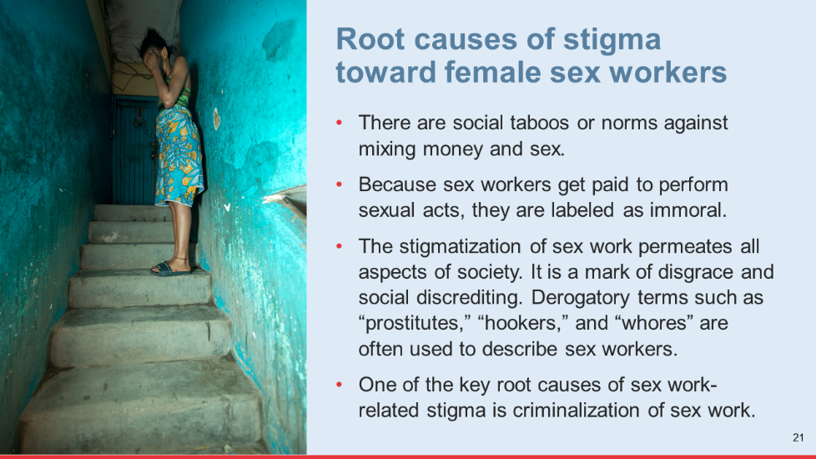

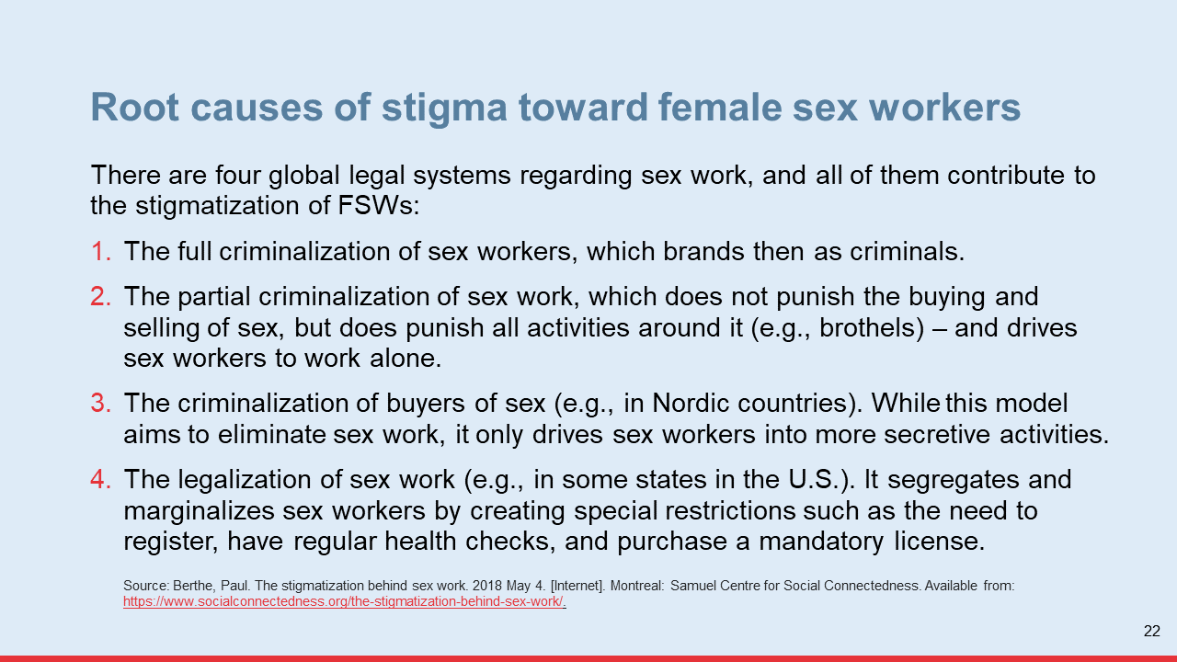
- Promote a brief group discussion by asking the following questions (5 minutes):
What do social norms in this country say on the exchange of sex for money?
Which of the four global systems on sex work do you think exists in this country?

Facilitation Notes and Tips
To prepare for this learning activity you should become acquainted with the laws/policies regarding the criminalization of sex work in your local context.
Please consider preparing a slide to share information on this with participants.
- Answer any questions participants may have about the root causes of stigma toward sex workers and then end the session by sharing the key messages below.
Key Messages:
End this session with the following key messages:
Social norms against selling sex and the criminalization of sex work are two of the main drivers of stigma against FSWs.
The stigma experienced by FSWs impacts their family, including their children. Children of FSWs are often stigmatized and rejected in their communities because of their mother’s involvement in sex work. They experience stigma by association.
Stigma is a risk factor for children of FSWs because it contributes to their social exclusion and isolation, which in turn, increases their vulnerability to abuse and exploitation. Stigma also makes it difficult for service providers to reach children of FSWs and this ultimately impacts their ability to access essential services. Stigma and discrimination also affect children’s psychological well-being and mental health.

Session 1.3: The Realities and Challenges of FSWs
Time: 50 minutes
Learning Objectives:
After completing this session, participants will be able to describe:
The key socioeconomic factors that drive women, including those who are mothers, into sex work
The challenges FSWs experience in their everyday lives
Learning Methods: Case studies, discussion in pairs and in small groups
Materials:
Handout #1: Stories of Sex Workers
Handout #2: Issues Faced by Sex Workers
Training slides #23–24
Prepare:
Make a copy of handouts #1 and #2 for each participant.
Introduction:
Introduce this session by sharing the following information with participants:
The family-centered approach used in orphan and vulnerable children (OVC) programs requires that OVC program implementers work closely with children’s parents or primary caregivers, including those who are FSWs. Therefore, it is critical that program implementers understand the difficult and complex lives of FSWs.
This session will help participants understand better the social and economic factors that drive women who are mothers to engage in sex work, and the risks they are exposed to in their everyday lives.

Learning Activity 1: Stories of Sex Workers (30 minutes)
- Explain to participants that they will now learn about the lives of some FSWs and the challenges and risks they have experienced.
- Distribute handout #1 (Stories of Sex Workers). Explain that these are real stories of FSWs. They will read the stories in silence, and then have a discussion with the person sitting closest to them using the questions on the screen (show slide #23) (20 minutes).
- When the time for the discussion is up, invite some participants to share their responses to the questions (10 minutes).
- Thank participants for sharing the results of their discussion. Ask them to stay in pairs for the next activity.
Tip for Virtual Implementation
Send the handout to training participants before the training session, so they have it at hand for the exercise.
Eliminate the discussion with another person and then sharing with the larger group. Simply show the questions in the slide and give participants the opportunity to respond to each question (one at a time) when they use the “raise your hand” icon. Make sure as many participants as possible participate in the discussion.

Learning Activity 2: Issues Faced by Sex workers (20 minutes)
- Explain to participants that the next activity will help them learn more about some of the issues commonly faced by FSWs as a result of stigma and discrimination.
- Distribute handout #2 (Issues Faced by Sex Workers) to each participant. Explain they will first read the handout and reflect on it in silence (5 minutes), and then they will have a brief discussion with the person next to them using the questions on the screen (show slide #24) (10 minutes).
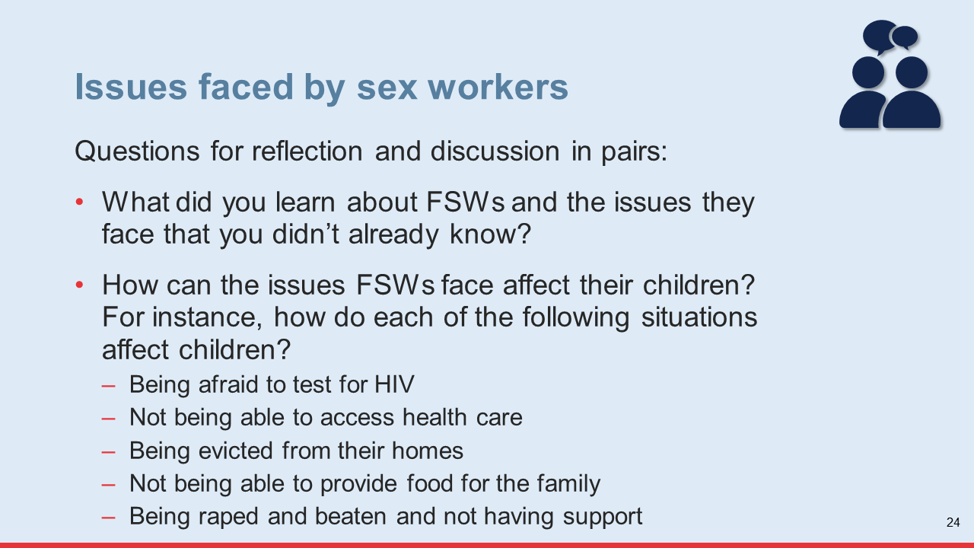
- Invite some of the participants to share the results of their discussion (5 minutes).
Tip for Virtual Implementation
Send the handout to training participants before the training session, so participants have it at hand for the exercise.
Eliminate the discussion with another person and then sharing with the larger group. Simply show the questions in the slide and give participants the opportunity to respond to each question (one at a time) when they use the “raise your hand” icon. Make sure as many participants as possible participate in the discussion.

Facilitation Notes and Tips
In preparation for this session, consider the possibility of inviting a representative from a local organization that works with FSWs to participate in a panel. This person should share what their organization has learned about the challenges FSWs experience in the local context, as well as some of the strengths and positive elements they have seen in FSWs’ lives and families that could help mitigate risks for children (e.g., love for their children, valuing education).
Key Messages:
End this session with the following key message:
- FSWs is a complex population. It is critical that OVC program implementers understand the realities and challenges that FSWs face, so they can provide helpful services in a nonjudgmental way and also mitigate risks for their children.

Session 1.4: The Risks and Vulnerabilities of Children of FSWs
Time: 1 hour
Learning Objectives:
After completing this session, participants will be able to:
Identify and describe the risk factors children of FSWs are commonly exposed to, and the vulnerabilities they experience as a result of these risks.
Learning Methods:
Discussion and work in small groups
Materials:
Handout #3: Risks Experienced by Children of Female Sex Workers
Slide #25
Flip chart paper
Markers
Prepare:
Make a copy of handout #3 for each participant
Introduction:
Introduce this session by sharing the following information with participants:
Children, especially young children, are naturally vulnerable because they depend on others to make decisions for them and satisfy their basic needs. Some groups of children, however, are even more vulnerable due to their exposure to a combination of many health, social, and economic risk factors. Children of FSWs is one of these groups.
In this session they will learn more about the risks and vulnerabilities of children of FSWs.

Learning Activity 1: The risks faced by of children of FSWs (1 hour)
- Explain to participants they will now do an exercise in small groups that will help them understand better the risks children of FSWs are exposed to, and their vulnerabilities.
- Separate participants into four groups and ask each group to choose one of the four PEPFAR OVC service delivery domains (healthy, safe, schooled, and stable) to work on during the exercise. Then, distribute handout #3 (Risks Experienced by Children of Female Sex Workers), flip chart paper, and markers to each group (5 min.)
- Provide instructions for the exercise using slide #25. The groups will have 20 minutes for this exercise.
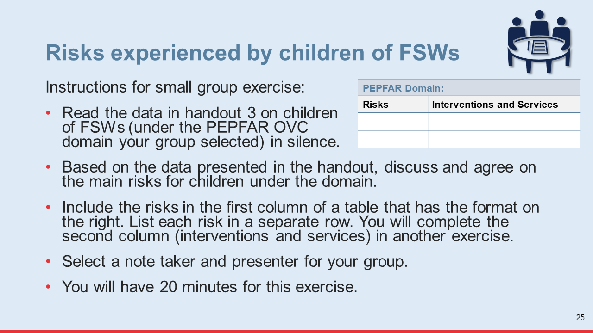
- When the time for group work is up, give each group 5 minutes to present the risks they identified (20 minutes). After each group presents:
Allow other groups to provide feedback.
Refer to the table below to make sure the groups have identified these risks in their respective domains. Discuss any challenge in the table that has not been identified and make sure participants include it in their respective table. Please note that the risks included in this table are not all the risks experienced by CFSWs. They are simply critical risks that participants should not forget about.
Encourage the groups to identify and discuss any risk factors that cut across the different domains.
Encourage the groups to identify any additional risks children of FSWs may experience in the local context (where the training is taking place) that are not listed in the handout.

Risks Commonly Experienced by Children of FSWs
PEPFAR Domain: Healthy | PEPFAR Domain: Schooled
- Frequent illnesses due to lack of access to preventive health care  - HIV infection, especially through mother-to-child transmission (MTCT) or sexual abuse  - Being HIV positive and not being diagnosed and placed on treatment due to lack of access to HIV testing services (HTS)  - Interrupting antiretroviral therapy (ART) due to lack of parental support, lack of awareness of HIV status, lack of food, and lack of money for transport to the health facility  - Malnutrition (especially in age <5) due to lack of sufficient and nutritious food | - Lack of birth certificate (could affect school enrollment)  - Poor school attendance due to frequent illnesses, lack of parental monitoring and lack of school resources  - Poor school performance due to frequent school absences and lack of parental support  - School dropout due to lack of money for school fees and school materials  - Stigma and discrimination by other students and/or school administration, if the child’s mother is known to be a sex worker
PEPFAR Domain: Safe | PEPFAR Domain: Stable
- Neglect (especially infants and young children), due to lack of proper parental care, lack of access to child-care, social isolation  - Physical violence due to parental stress and lack of parenting skills  - Sexual violence (by pimps, FSW clients, others)  - Psychosocial distress due to mistreatment and rejection in their families, communities  - Child labor due to extreme poverty | - Extreme poverty due to lack of regular or steady household income  - Food insecurity due to lack of regular or steady household income  - Inability to weather household shocks due to limited savings and irregular income streams

Tip for Virtual Implementation
Send the handout to training participants before the training session, so participants have it at hand for the exercise.
For step 2 (discussion in small groups), use the “breakout room” function to place participants in virtual rooms and assign time for the discussion. Once you have done this, participants will be automatically transferred to their room, and when the time for the discussion is up, they will automatically be brought back to the large group.
- Thank participants for their group work. End this learning activity with a brief group discussion on the risks faced by CFSWs using the following questions (15 minutes):
Which risks faced by CFSWs do you think are similar to the risks faced by other vulnerable children or children in general?
Which risks faced by CFSWs do you think are unique (or increased) for this population (CFSWs)?
- Thank participants for their contributions. Ask them to stay in their groups since they will continue to work together in the next exercise. Also, ask them to keep the flipchart paper that they wrote on since they will use it in the next exercise.
Key Messages:
End this session with the following key messages:
Children of FSWs often experience a multitude of risks that can compromise their health, development, and overall well-being, and prevent them from reaching their full potential. It is critical that programs/organizations work to reduce these risks by tailoring services to meet their special needs and the special needs of their families.
FSWs and their children are at particular high risk of gender-based violence (GBV) and violence against children (VAC), so it is crucial that community case workers are properly oriented on the OVC program’s Child Protection Policy and Procedure, as well as the program’s VAC/GBV reporting protocol so they are able to report cases and ensure timely access to comprehensive post-violence care services.

Module Two Learning Activities

Session 2.1: Addressing the Vulnerabilities and Needs of Children of FSWs
Time: 1 hour and 25 minutes
Learning Objectives:
After completing this session, participants will be able to:
Identify the interventions and services under the PEPFAR OVC service domains that are critical for children of FSWs and their families
Identify the referral relationships that can facilitate access to services for children of FSWs and their families
Learning Methods:
Discussion and work in small groups
Materials:
Slides #27–28
Flip chart pages with the risk factors under each PEPFAR OVC domain (from previous learning session)
Flip chart paper
Markers
Tape
End-of-day Evaluation Form
Prepare:
Not required
Introduction:
Introduce this session by sharing the following information with participants:
Children of FSWs are exposed to many health and socioeconomic risks that can threaten their present and future physical, emotional, and mental well-being. To reduce these risks OVC programs need to tailor a package of services that responds to their unique risks and needs.
Learning Activity 1: Developing a package of services for children of FSWs and their families (40 minutes)
- Explain to participants that in the next exercise they will identify interventions and services that can help reduce or eliminate the risks they identified in the previous exercise. Provide instructions for the exercise using slide #27. The groups will have 20 minutes for this exercise.
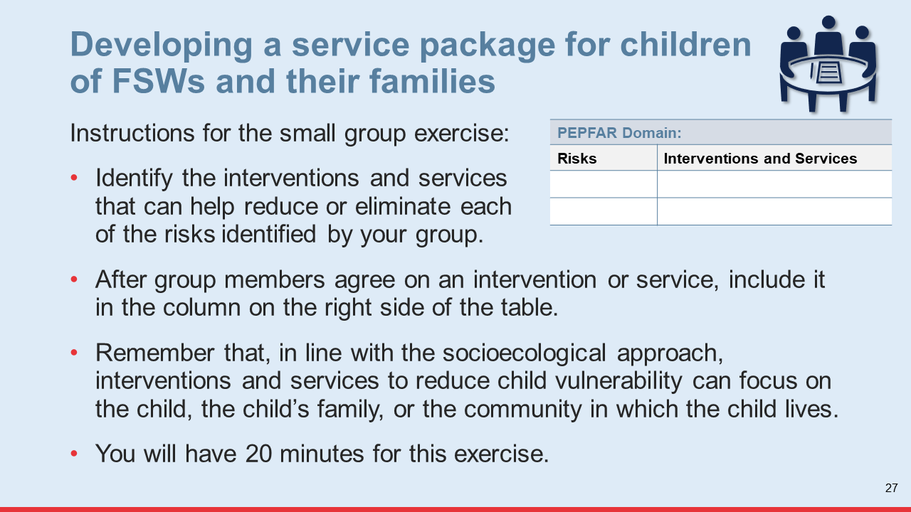
- After providing instructions, make sure participants are in the same groups in which they identified the risks experienced by children of FSWs. Distribute flip chart paper and markers to each group and ask each group to select a note taker and presenter.
- When the time for the group work is up, give each group 5 minutes to present the results of their work (20 minutes). After each group presents:
Allow the other groups to provide feedback.
Discuss if any of the interventions/services proposed by the group could also help reduce risks in other domains.
Refer to the package of services below to determine if any critical interventions or services were left out. Explain the importance of any such intervention/service, and make sure it is included in the group’s table.

Key Interventions and Services for CFSWs and Their Families
Risks | Interventions and Services
PEPFAR Domain: Healthy
HIV infection | HIV prevention education for adolescents ages 9–17  Linkage/referral of sexually active adolescents to adolescent sexual and reproductive health (ASRH) for family planning (FP), condom provision, pre-exposure prophylaxis (PrEP), HTS, etc.  Linkage of adolescent girls and young women (AGYW) age 10–17 to DREAMS (where this program exists and overlaps with the OVC program)  Mobilize biological children (<19 years) of HIV-positive FSWs for index testing in coordination with KP and HIV clinical partners  Linkage/referral to HTS  Linkage to ART for newly identified children and adolescents living with HIV (CALHIV)  Support pregnant FSWs and new mothers, particularly adolescents, to adhere to prevention of mother-to-child transmission (PMTCT) (if HIV positive)  Support access to HTS among HIV-exposed infants (HEIs) for early infant diagnosis (EID)
HIV treatment interruption | Home visits to monitor ART adherence and provide adherence support  ART literacy education for CALHIV and caregivers who are FSWs  Reminders of ART and viral load (VL) testing appointments  Support to attend ART and VL testing appointments (e.g., transport and escorting)  Linkage to a CALHIV peer support group  Caregiver HIV status disclosure support  Linkage to sources of food support  Linkage to social grants  Linkage to economic-strengthening interventions  Coordinate efforts to trace CALHIV and families who have defaulted ART and are lost to follow-up (LTFU) with KP and clinical programs
Frequent illnesses due to lack of access to health care | Provision of health insurance cards  Referrals to age-appropriate preventative and curative health services  Linkage of children less than age 5 to child survival services (e.g., immunization, mid upper-arm circumference [MUAC] assessment, nutrition assessment, counseling, and support [NACS], supplemental/therapeutic feeding  Water, sanitation, and hygiene (WASH) counseling
PEPFAR Domain: Schooled
Poor school attendance  Poor school performance  Lack of parental support  School dropout  Lack of birth certificate | Child and parent awareness raising on the importance of education  Linkage to social grants  Proviso of scholarships (for payment of school fees, uniforms, and school supplies)  Linkage to economic-strengthening interventions  Provision of sanitary pads/menstrual hygiene support to adolescent girls  Monitoring of school attendance  Academic support/tutoring  Support with birth registration
PEPFAR Domain: Safe
Neglect, and physical and sexual violence  Lack of access to child-care  Stigma related to sex work and sexual violence  Child labor | Parenting education for caregivers who are FSWs  Linkage of FSWs with infants and young children to child-care options  Education on VAC/GBV for children and their caregivers who are FSWs  Screening for risk of VAC/GBV  Linkage of VAC/GBV survivors to comprehensive post-violence care  Support for children and caregivers who are FSWS for dealing with stigma  Linkage to economic-strengthening interventions and increase parental awareness about the hazards of child labor for children
PEPFAR Domain: Stable
Poverty/lack of steady income  Food insecurity | Household gardens  Linkage to local food supplementation  Linkage to social grants  Linkage to economic-strengthening interventions
- Remind participants that:
Interventions and services can be implemented/provided directly by their organization/program or through referrals to other service providers.
The actual services each child and their family receive will depend on their individual needs.
The individual needs of a child and his/her family should be identified through a needs assessment.
- Thank the groups for their work and ask them to tape their tables to a wall so they can refer to it in the next exercise.
- Ask participants to continue in their small groups for the next exercise.
Tip for Virtual Implementation
For the discussion in small groups, use the “breakout room” function to place participants in virtual rooms and assign time for the discussion. Once you have done this, participants will be automatically transferred to their room, and when the time for the discussion is up, they will automatically be brought back to the large group.
Learning Activity 2: Establishing linkages and referrals for service delivery to children of FSWs (45 minutes)
- Explain to participants that the next exercise will help them identify service providers with whom they need to establish a referral relationship in order to help children of FSWs access services.
- Provide instructions for the exercise using slide #28. The groups will have 20 minutes for this exercise.
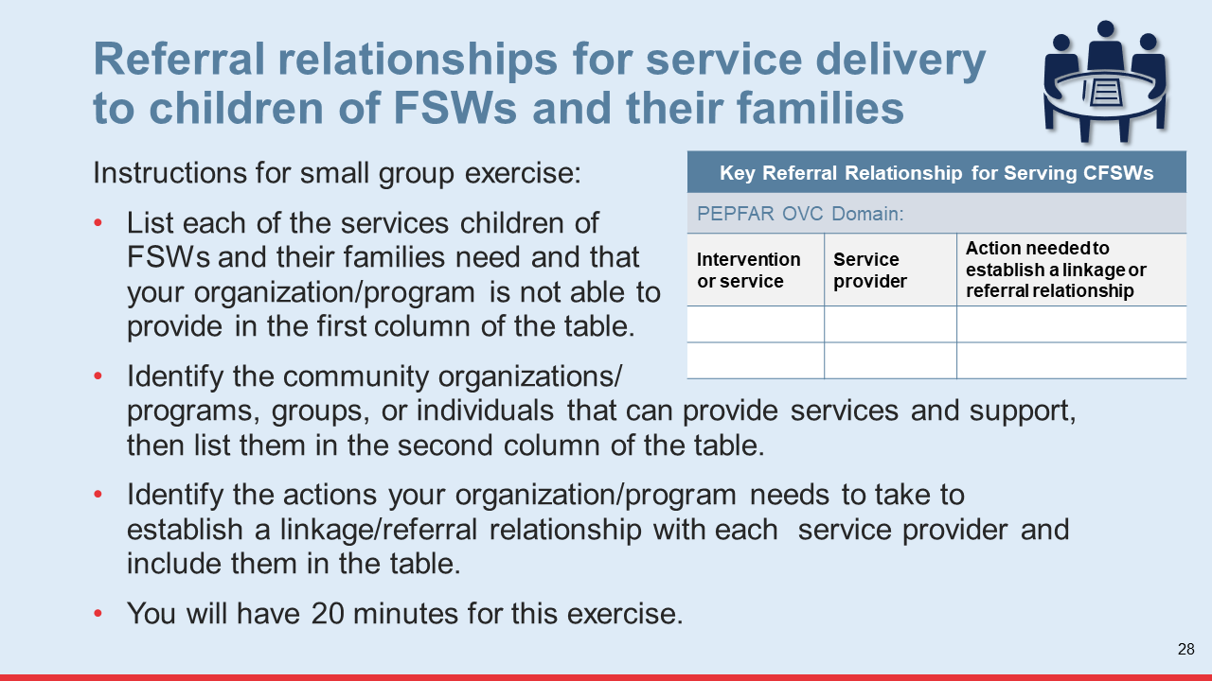
- Give each group flip chart paper and markers and ask each group to select a note taker and presenter.
- When the time for the exercise is up, give each group 5 minutes to present the results of their work (20 minutes). After each group presents, make sure you allow other groups to provide feedback and promote discussion across the groups.
- Thank the groups for their contributions and provide the following reminders (5 min.):
It is important that their organization establish a memorandum of understanding (MOU) with any service provider to whom they need to refer children, but particularly with HIV clinical service providers. MOUs should describe the bi-directional nature of the referral relationship.
The MOU should clearly articulate the referral and counter-referral mechanisms, and who is the referral focal point in each organization.
Service providers must be included in the OVC service directory that is provided to community case workers.
The directory should include information on the location/address of the service provider, hours of operation, and contact information for the person responsible for managing referrals.
Tip for Virtual Implementation
For the discussion in small groups, use the “breakout room” function to place participants in virtual rooms and assign time for the discussion. Once you have done this, participants will be automatically transferred to their room, and when the time for the discussion is up, they will automatically be brought back to the large group.
Key Messages:
End this session with the following key message:
The needs of children of FSWs and their families are complex, and it is very difficult for one single organization/program to meet all their needs. Thus, it is important to establish strong referral relationships with other service providers and to leverage all available resources and supports available in the community, including those offered by community groups and individuals.
Facilitation Note and Tip
Distribute the end-of-day evaluation form to participants. Explain that the information they provide in this form will help you (the facilitator) make any necessary improvements for tomorrow (5 minutes).

Session 2.2: Strategies for Finding and Reaching Children of FSWs with Services
Time: 1 hour and 55 minutes
Learning Objectives:
After completing this session, participants will be able to:
Identify the most common challenges for finding and delivering services to children of FSWs
Describe key strategies organizations/programs can use to identify and reach children of FSWs with services
Describe the benefits of and key steps for establishing a partnership with a KP program
Learning Methods:
Small group discussion
Presentation
Case study
Materials:
Training slides #29–40
Handout 4: Case Study: Collaboration between a KP and an OVC Program
Flip chart paper and markers (if not using slides)
Prepare:
Make a copy of handout #4 for each participant
Introduction:
Introduce this session by sharing the following information with participants:
Finding children of FSWs and reaching them with services can be difficult. In this session they will learn about some of the challenges they may experience in finding and reaching this population, as well as some of the strategies to overcome these challenges.

Learning Activity 1: Challenges for finding and delivering services to FSWs and their children (45 minutes)
- Explain to participants they will now do an exercise to identify challenges to identifying and delivering services to FSWs and their children . Provide instructions for this exercise using slide #29.
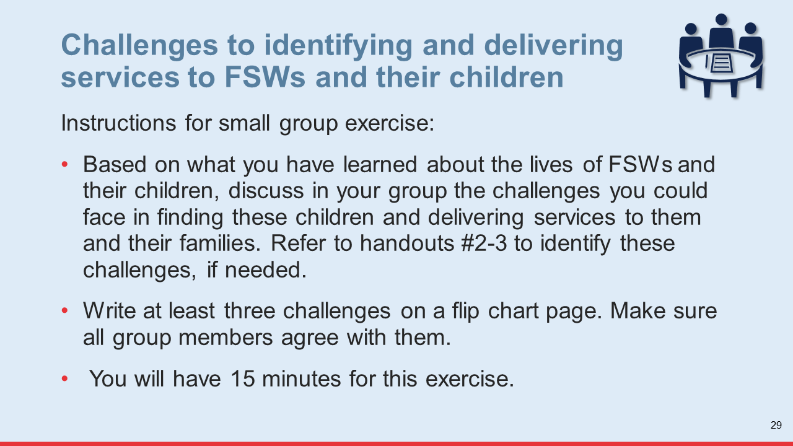
- Ask participants to separate into four small groups and to select a note taker and presenter. Give flip chart paper and markers to each group (15 minutes).
Facilitation Note and Tip
Participants spent considerable time working in the same groups during the previous learning activities, so make sure they form new small groups for this exercise.
- When the time for the group exercise is up, ask each group to describe the challenges they identified (10 minutes).
Facilitation Notes and Tip
To save time, after the first group presents ask subsequent groups to present challenges that have not been previously presented.
- Once all groups have presented, thank them for their contributions.

Tip for Virtual Implementation
For the group exercise in step 2, instead of asking participants to break out into small groups, ask them to share their ideas about challenges to finding and delivering services to CFSWs and their caregivers in the large group. Write the challenges as participants identify them and then share the final list in the chat box.
- Share some of the most important challenges to finding and delivering services to FSWs and their children using slides #30–31 (20 minutes). As you discuss each challenge:
Acknowledge if the challenge was already identified by the groups during the previous exercise
Discuss the implications of each challenge for service delivery to FSWs and their children
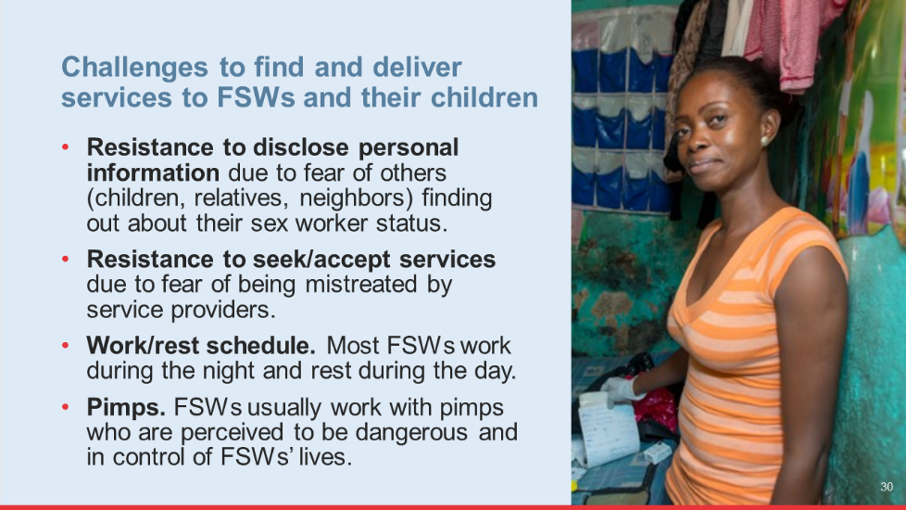

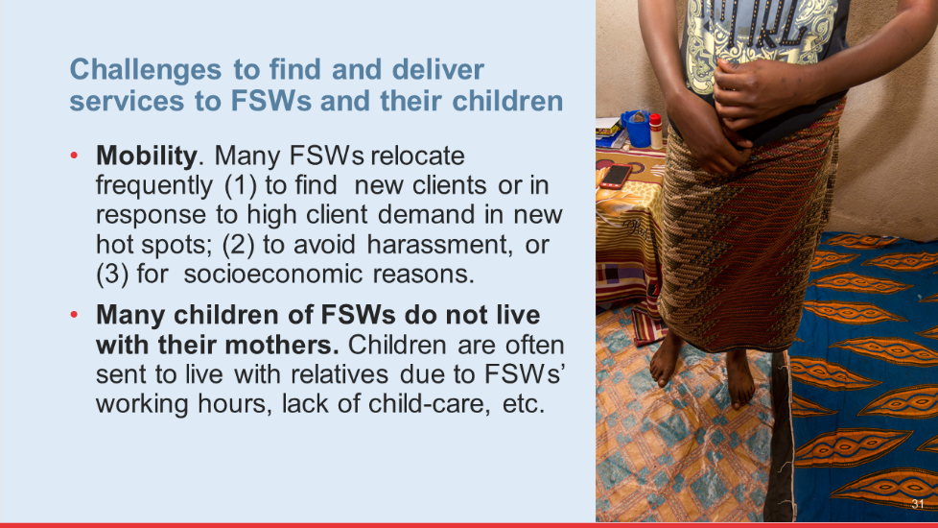
- Answer any questions participants may have about the challenges you presented and then move on to the next activity. Ask participants to stay in their groups.
Learning Activity 2: Strategies to overcome challenges to finding and delivering services to FSWs and their children (45 minutes)
- Explain to participants they will now do another exercise in their small groups. Provide instructions for the exercise using slide #32.
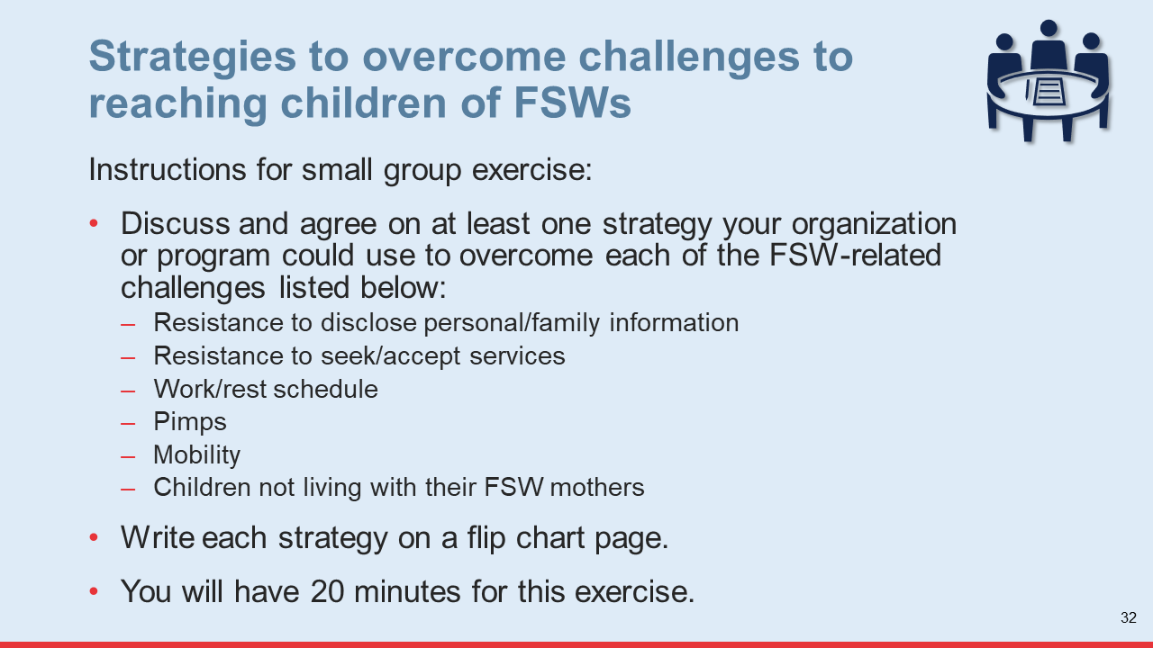
- Ask each group to select a different note taker and presenter. Provide flip chart paper and markers to the groups (20 minutes).
- When the time for the exercise is up, give each group 5 minutes to share the strategies they identified. After each group presents, allow the other groups to react to the strategies that have been shared and say if they agree or not (10 minutes).
Facilitation Tip:
After the first group presents ask subsequent groups to only present strategies that have not been previously presented. This will help save time.
- Thank participants for their contributions and ask them to stay in their groups.
Tip for Virtual Implementation
For the discussion in small groups, use the “breakout room” function to place participants in virtual rooms and assign time for the discussion. Once you have done this, participants will be automatically transferred to their room, and when the time for the discussion is up, they will automatically be brought back to the large group.
- Share some of the strategies OVC programs can use to find and reach FSWs and their children using slides #33–39. As you present each strategy, discuss with the group whether that strategy would work or not in the local context (15 minutes).
Facilitation Tip:
In preparation for this activity, consider inviting a representative from a local KP program to present on some of the strategies they currently use to identify, reach, and build trust with FSWs, particularly those who are mothers. Alternatively, you could gather information from the KP program and prepare a slide with examples of strategies being used locally.

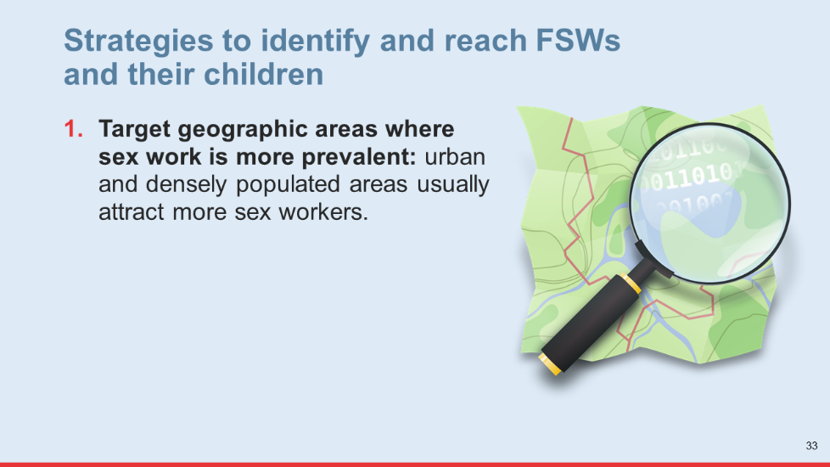

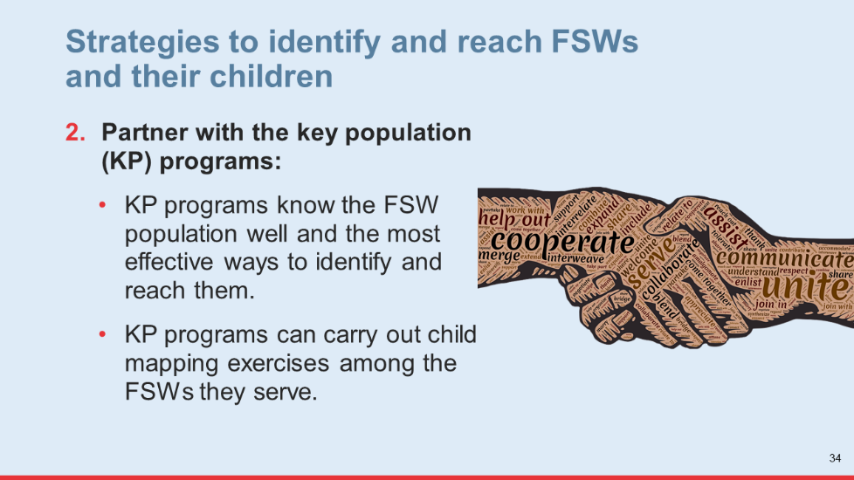

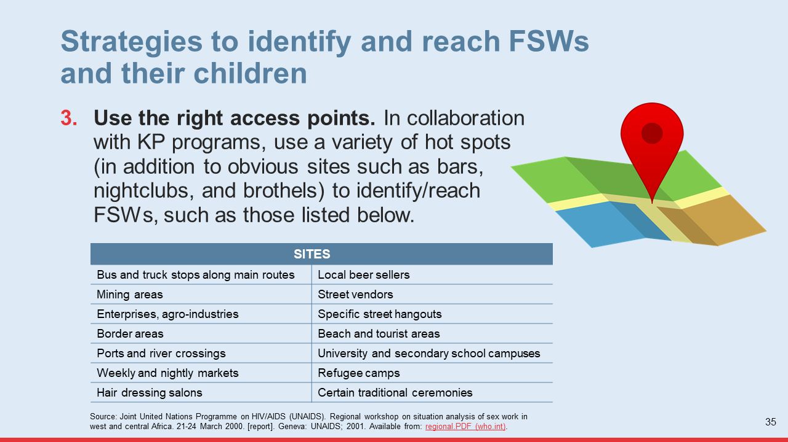

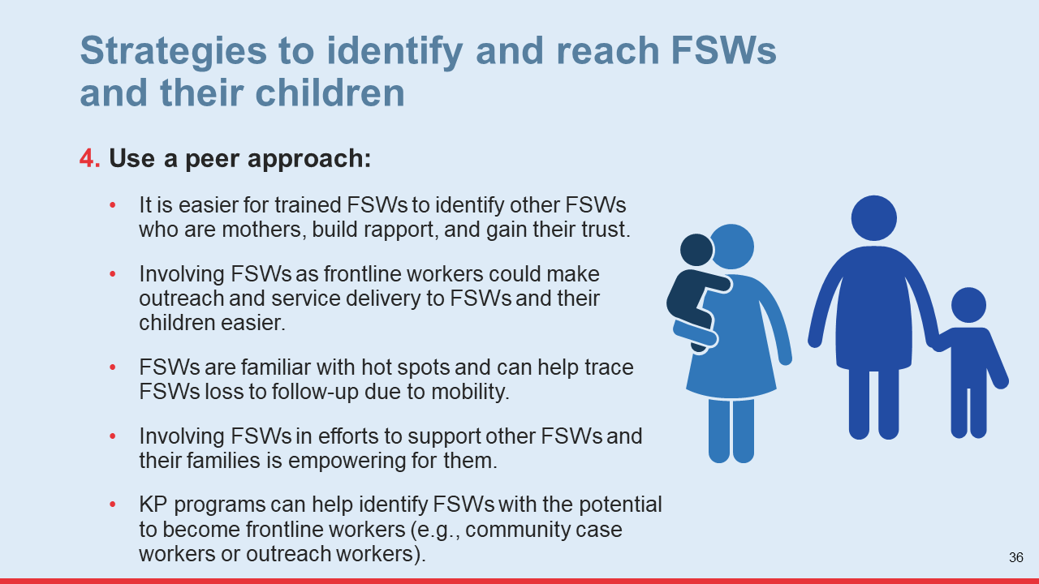

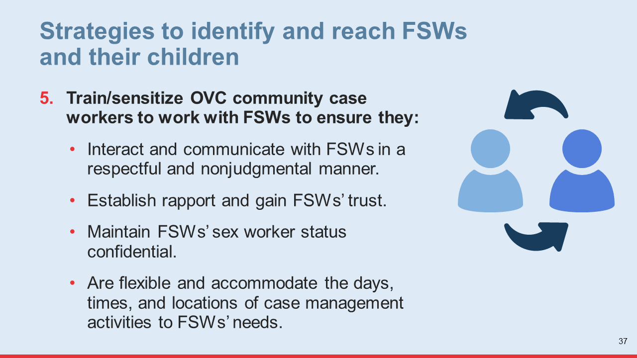

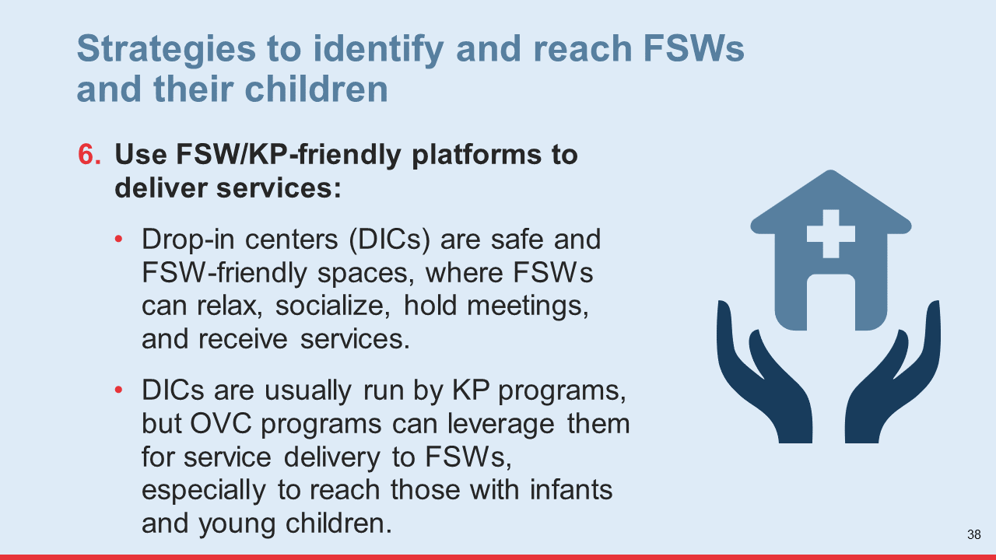

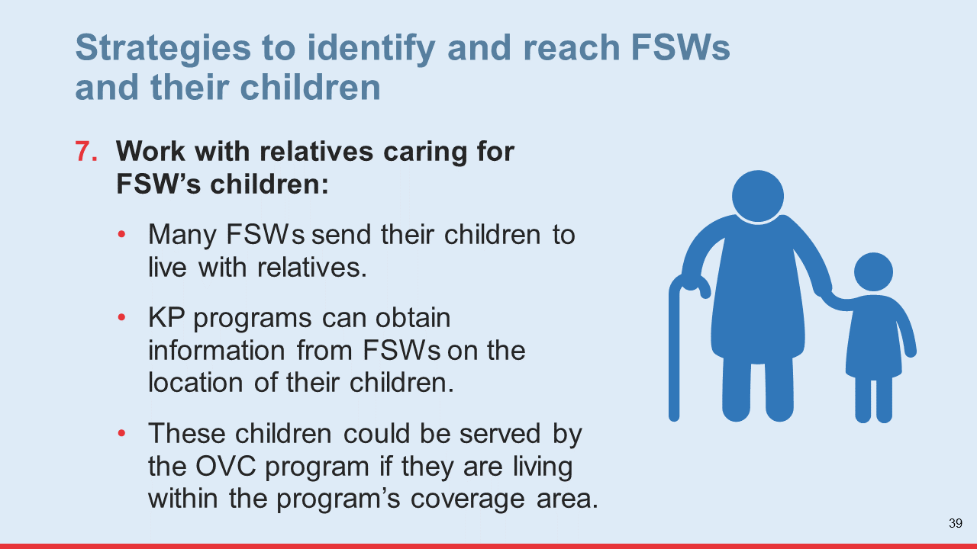
- Answer any questions participants may have about the strategies presented and then move on to the next learning activity.

Learning Activity 3: Collaboration between OVC and KP programs (25 minutes)
- Explain to participants that, as they learned in the previous learning activity, it is critical that OVC programs work in partnership with KP programs to reach children of FSWs and their caregivers. In this activity they will review and analyze a case study on an effective partnership between these two types of programs in Malawi.
- Ask participants to group themselves by organization. Then, distribute handout #4 to each participant and provide instructions for the exercise using slide #40. The groups will have 15 minutes for this exercise.
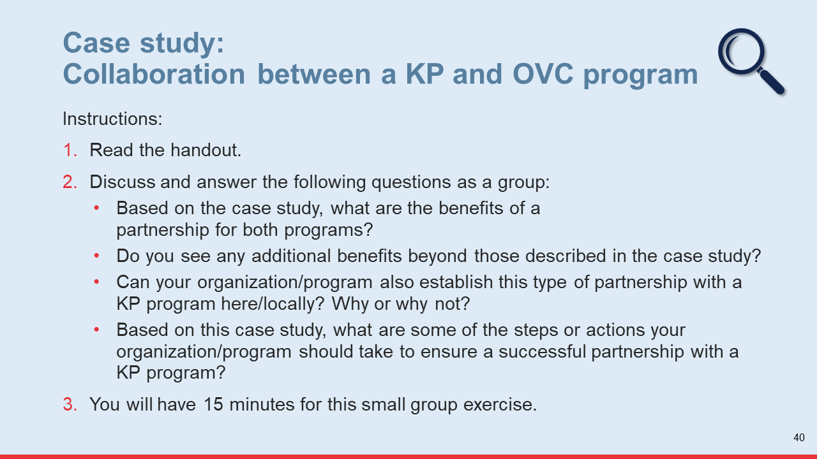
- When the time for the small group exercise ends, ask a representative from each group to share the results of their discussion (10 minutes).
Key Messages:
End this session with the following key messages:
Although children of FSWs are a hard-to-reach population, effective strategies are available to reach them.
Collaboration between OVC and KP programs is crucial. OVC program implementers must work in partnership with KP programs to find the most effective strategies for finding and providing services to CFSWs.

Session 2.3: Principles and Personal Values for Delivering Safe and Acceptable Services to Children of FSWs and their Families
Time: 1 hour and 10 minutes
Learning Objectives:
After completing this session, participants will be able to:
Identify and describe the key principles and values that contribute to making services and service delivery activities safe and acceptable for FSWs and their children.
Learning Methods:
Small group discussion
Gallery walk
Materials:
Training slides #41–42
Flip chart paper
Markers
Handout #5: Principles for Delivering Services to FSWs and Their Children
Handout #6: Values that Will Guide My Work with FSWs and Their Children
Prepare:
Make copies of handouts #5 and 6 (one for each participant).
Introduction:
Introduce this session by explaining to participants they will learn about the principles and personal values that can help make service delivery activities safe and acceptable for FSWs and their children.

Learning Activity 1: Principles for delivering services to children of FSWs (35 minutes)
- Explain to participants that the same principles that guide service delivery to vulnerable children in OVC programs also apply to children of FSWs. However, because this is a highly stigmatized and socially marginalized group of vulnerable children, some principles are particularly important to follow when delivering services to them.
- Explain they will now have a discussion in small groups on principles for delivering safe and acceptable services to FSWs and their children. Ask participants to group themselves by organization. They may also work in pairs or alone depending on the number of people from each organization participating in the training.
- Distribute handout #5 (Principles for Delivering Services to FSWs and Their Children). Ask the groups to first read the handout and then have a discussion using the questions in slide #41. They will have 20 minutes.
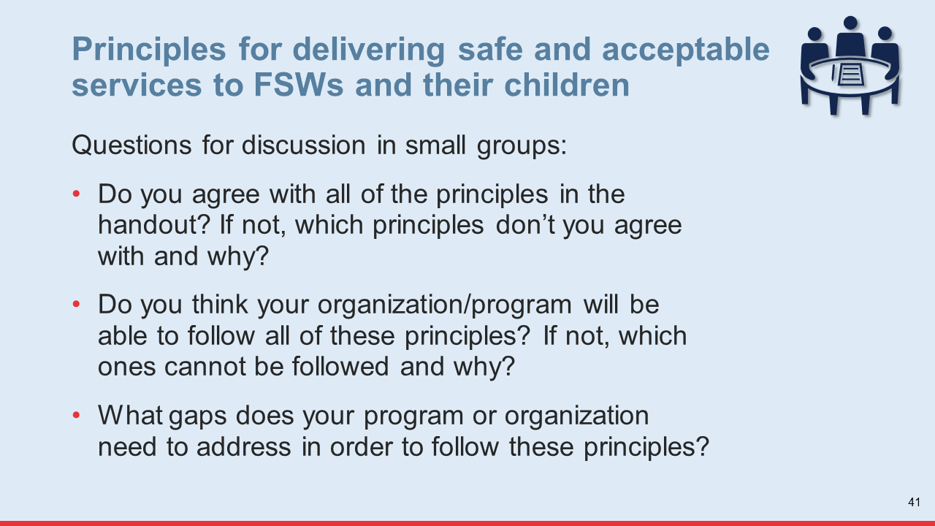
- When time for discussion in small groups is up, give each group 5 minutes to share the results of their discussion (15 minutes).
- Ask participants to hold on to the results of their discussion and to stay in their groups since they will continue to work together in the next learning activities.
Tip for Virtual Implementation
Send the handout to training participants before the training session, so participants have it at hand for the exercise.
For step 2 (discussion in small groups), use the “breakout room” function to place participants in virtual rooms and assign time for the discussion. Once you have done this, participants will be automatically transferred to their room, and when the time for the discussion is up, they will automatically be brought back to the large group.
Learning Activity 2: Personal values for delivering safe and acceptable services to FSWs and their children (35 minutes)
- Explain to participants that, after learning about the principles their organizations/programs should follow to deliver safe and acceptable services to FSWs and their children, they will now learn about the personal values that can help providers provide services that are acceptable and safe for this population.
- Explain they will now do a “gallery walk” exercise. Provide instructions for this exercise using slide #42 (20 minutes).
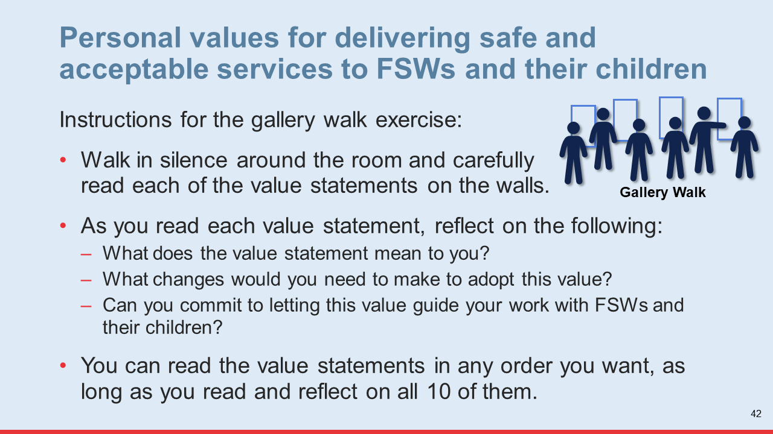

Facilitation Notes and Tips
As participants move around the room, make sure there is total silence so they can concentrate and reflect on each statement.
To ensure participants have time to reflect on all 10 statements, walk around the room in silence every 5 minutes with a sign that tells them how many minutes they have left for the exercise.
- Once the time for the gallery walk is up, ask participants to go back to their seats. Use the questions below to promote a discussion about the gallery walk experience. Sharing should be voluntary (10 minutes).
What do you think about the value statements you just read?
  - Which values do you consider most important? Why?
  - Which values ones do you consider less important? Why?
Is there a statement you did not agree with? If so, which one and why?
Are there other values you think are missing and should be added to the list of value statements? Which one(s) and why?

Tip for Virtual Implementation
Substitute the gallery walk exercise with an individual reflection exercise. Put the value statements on a slide. Project the slide on your screen and give participants 15 minutes to reflect on the statements using the questions in slide #41.
Once the time for reflection is up, promote a discussion using the questions in step 3.
- Distribute a copy of handout #6 (Values that Will Guide My Work with FSWs and Their Children). Explain that these are the same values that were posted on the walls during the gallery walk. Ask them to sign the statement as a symbol of personal commitment to follow these values. Suggest that they tape the signed handout to a wall near their desk when they return to their workplace as a reminder of the commitment they have made (5 minutes).
Tip for Virtual Implementation
For step 4, send the handout to training participants before the training session, so they have it at hand for the exercise.
Key Messages:
End this activity by thanking participants for sharing their thoughts with the group. Encourage them to revisit the list of personal values in six months as a way of holding themselves accountable to adopt these values.

Session 2.4: Action Planning to Provide Safe and Acceptable Services to Children of FSWs and their Families
Time: 1 hour and 25 minutes
Learning Objectives:
After completing this session, participants will be able to:
Describe the actions their organizations or programs need to take to provide safe and acceptable services to children of FSWs and their families.
Learning Methods:
Work in small groups
Materials:
Handout #7: Organization/OVC Program Self-Assessment
Handout #8: Areas for Improvement in My Organization
Handout #9: Action Plan to Provide Safe and Acceptable Services to FSWs and Their Children in My Organization or OVC Program
Prepare:
Make copies of handouts #7, #8, and #9 (one for each participant).
Introduction:
Introduce this session by sharing the following information with participants:
This session will lead them through a process of self-assessment and planning that will allow them to apply what they have learned and walk out of the training with an action plan for their organization or program to provide safe and acceptable services to FSWs and their children.

Learning Activity 1: Assessing and improving the capacity of my program or organization to provide safe and acceptable services for FSWs and their children (30 minutes)
- Explain to participants they will now work in small groups to assess the capacity of their organization/program to provide safe and acceptable services to FSWs and their children. Participants will group themselves by organization.
- Distribute the self-assessment form to each group (handout #7). Explain they should first discuss each assessment criteria and agree on the response before marking their response on the form (10 minutes).
- When time for completing the self-assessment form is up, ask the groups to use the results of the self-assessment to identify the changes that need to be made within their organization/program to provide safe and acceptable services to children of FSWs.
- Distribute handout #8 and explain what information they should include in each column using the information below (20 minutes):
Challenges: List the key challenges identified through the self-assessment that could prevent your organization/program from delivering safe and acceptable services to FSWs and their children.
Root Cause(s): Identify the root cause of each challenge by asking yourself “why does this challenge exist?”
Changes/Improvements: For each challenge, identify a change or improvement action that can be implemented. Make sure the improvement addresses the root cause of the challenge.
- When time for completing the handout is up, ask each group to voluntarily share some of the challenges, root causes, and changes/improvement actions they identified (10 minutes).
- Thank participants for sharing their information with the group and move on to the next activity.
Tip for Virtual Implementation
Send handouts 7 and 8 to participants before the session. These forms should be completed per organization, so participants from the same organization should get together and complete the forms and come to the training prepared to share their work.

Learning Activity 2: Planning to make service delivery for FSWs and their children safe and acceptable (55 minutes)
- Explain to participants they will now develop an action plan to achieve the changes/improvements they identified in the previous exercise. Distribute handout #9 (Action Plan to Provide Safe and Acceptable Services for FSWs and Their Children in My Organization or OVC Program) and explain how they should complete it using the information below (40 minutes).
Improvement: Write the improvement you want to achieve.
Activities: Identify the activity/ies you will need to implement to achieve the improvement.
Time period: Include a specific timeframe for the activity/ies.
Person(s) responsible: Identify the person who will be responsible for implementing the activities.
Existing resources/strengths: Identify any existing resources and/or strengths within your program/organization you can use or build upon to achieve the improvements.
Resources needed: Identify the resources your organization/program will need to carry out the activity (e.g., funds, tools, technical assistance).
Facilitation Notes and Tips
Walk around the room and provide any support the groups may need while they are developing their action plan.
- When time for completing the action plan is up, ask the groups to voluntarily share the activities they have planned to achieve their improvements (15 minutes). Allow the members of the groups to provide feedback and recommendations.
Tip for Virtual Implementation
Send handout 9 to participants before the training session. The action plan form should be completed per organization building on the previous exercise, so participants from the same organization should get together and complete the action plan and come to the training prepared to share their plan.
- Thank the groups for the great teamwork. Ask each group to explain what they will do to get the support necessary to implement their action plan within their organization or program.

Key Messages:
End this learning activity by sharing the following key messages:
Children of FSWs and their families are a complex population with multiple elevated risk factors. Given the intense and complex nature of the support they need, it is absolutely critical that organizations/programs are well equipped to serve them. A continuous process of self-assessment and capacity improvement would greatly contribute to the provision of quality care to this population.
It is particularly important that the community cadres that directly interact with CFSWs and their caregivers (e.g., case workers) receive appropriate supportive supervision and routine in-service training to continuously strengthen their skills and capacity to provide quality care and support. They should be encouraged to ask for help with especially complex/difficult cases and receive psychosocial support to prevent and mitigate the risk of burnout and ensure their retention.

Training Closing Activities
Time: 50 minutes
Objectives:
The objectives of this session are to:
Assess participant’s post-training knowledge
Assess participant’s satisfaction with the training
Materials:
Post-training Questionnaire (Annex 3)
Training Evaluation Form (Annex 7)
Prepare:
Make copies of the post-training questionnaire and the training evaluation form for each participant
Activity 1: Post-training Questionnaire and Training Evaluation (20 minutes)
- Let participants know their feedback on the training and the results of their post-training questionnaire are important because they will help strengthen future trainings. Tell them you’d like to receive their honest, constructive criticism and specific recommendations on the evaluation form. Remind participants that the evaluation form and post-training questionnaire are anonymous.
- Distribute the post-training questionnaire and the training evaluation form and ask participants to complete them. Rather than collecting the completed forms from the participants, ask them to place the forms in a central location (e.g., on a chair or table), so they remain anonymous.
Activity 2: Closing (30 minutes)
- As the main facilitator of the training, thank participants for their active participation, enthusiasm, energy, honesty, and openness throughout the training. Remind them that action and change to deliver safe and acceptable services to FSWs and their children can start with each of them. Encourage them to implement the action plans they developed and follow through with the personal value commitments they have made (5 minutes).
- Ask if anyone would like to share any final thoughts or comments with the group (10 minutes).
- Allow a representative from the organization/program hosting the training or a local government representative to deliver a few words to close the training (5 minutes).
- Distribute certificates of participation (10 minutes).

Handouts
Module 1
Handout 1: Stories of Sex Workers
Handout 2: Issues Faced by Sex Workers
Handout 3: Risks Experienced by Children of Female Sex Workers

Module 2
Handout 4: Case Study: Collaboration between a KP and OVC Program in Malawi
Handout 5: Principles for Delivering Services to FSWs and Their Children
Handout 6: Personal Values that Will Guide My Work with FSWs and Their Children
Handout 7: Organization/OVC Program Self-Assessment
Handout 8: Areas for Improvement in My Organization
Handout 9: Action Plan to Provide Safe and Acceptable Services for FSWs and Their Children in My Organization or OVC Program

Handout 1: Stories of Sex Workers
Bernadette was born into a family of 11. She lost both her parents when she was 7 years old and was raised by her sister and later by her grandparents. With little financial support from her family, she found herself going hungry at school and started having sex in exchange for food, pens, and books. She soon became pregnant and dropped out of school at 18. Today she is a mother of six children. Her last partner was abusive and left her destitute, so she turned to selling sex in 2018, seeing it as the best option to survive.

Maria, 36, was married for 11 years, and worked selling farm produce with her husband. After suffering years of abuse, Maria was abandoned by her husband. She struggled to support herself and her young daughter, so she turned to sex work. “Sometimes clients will be violent, or they won’t pay. Two years ago, I had a client. We slept together but afterwards he didn’t pay. During sex, he deliberately broke his condom. Things got violent, and he knocked out my front tooth. And then afterwards he wouldn’t pay.”

Adeline has been a sex worker since 2005. Previously she had been married with two children, but after her divorce she found she could not support her family. She says: “A friend came to me and said, 'Why are you suffering? There's this alternative. You can make money with sex work.' I tried it and realized that I was making more than other ways to make money, so I decided to take this route. One night I was working, and a group of men beat me and my friend up. They left us naked with nothing. Another time, a client raped me. I never went to the police. The guy was well known in the area and had raped other women and would come after those who reported it. It was better to just keep quiet, so I did nothing.”

Jennifer, 26, is a single mother with two children. Her husband was a professional thief. When she asked him to leave his life of crime, he refused. They separated and divorced. In 2008, Jennifer felt that the only way to support her children was to go into sex work. “When my relatives heard that I had started doing sex work, I was chased away and told that I should never go back home. But blood is thicker than water and, later on, when I visited them, I found that they welcomed me. My two kids now stay with my mother. As a sex worker there are a number of challenges. Once a client paid in advance and came to my room. He asked me to go and buy chips, so I did but when I came back, I found that he had stolen my money and clothes. I intend to stop this [sex work] business. It’s really tough... If I continue, I feel I will die before my time.”

Source: Corthier, Isabel. Sex workers in Malawi deal with HIV, contraception and violence. 16 September 2019. [Internet]. London: BBC News. Available from: https://www.bbc.com/news/in-pictures-49164356.

Handout 2: Issues Faced by Sex Workers
Source: Joint United Nations Programme on HIV/AIDS (UNAIDS). The gap report 2014: sex workers. Geneva: UNAIDS; 2014. Available from: 06_Sexworkers.pdf (unaids.org).

Handout 3: Risks Experienced by Children of Female Sex Workers
Healthy:
A study conducted by Schwartz in Cote d’Ivoire found that only 59% of FSWs had received HIV testing before childbirth during their last pregnancy.¹
Another study conducted by Schwartz in South Africa found that nearly one-third of children with an HIV-positive FSW mother had never received HIV testing.²
In a study conducted by Rao in Cameroon, nearly 70% of HIV-positive mothers reported that none of their children had been tested for HIV before the age 5.³
In Malawi, data collected during a short-term project targeting children of FSWs revealed that 31% of biological children of FSWs had unknown HIV status, and 47% of them had an HIV-positive mother.
In an assessment conducted in an OVC program in Ethiopia: ⁴
- 20% of caregivers who were FSWs reported that their child aged 0–9 had been sick in the two weeks before the survey; 12% of children of FSWs aged 0–9 had diarrhea in the past two weeks, and 16% had had a fever.
- Only 14% of children of FSWs aged 2–9 had received all of the vaccinations needed for their age.
- FSWs more often used pharmacies and traditional practitioners to treat their children’s diarrhea than government health facilities.
Schooled:
In focus group discussions conducted by USAID staff and implementing partners in Cameroon, Ethiopia, India, and Tanzania, FSWs who were mothers reported not having enough money for school fees.⁵
In an OVC program assessment in Ethiopia:⁴
- 13% of adolescent children of FSWs aged 13–17 had dropped out of school the previous year. The main reason was lack of money for school fees; 55% of caregivers who were FSWs said their child was not in school due to lack of money for school fees.
- Nearly one-fourth of children of FSWs had missed at least one day of school in the prior week, and 8% had missed three to five days. The most common reason for missing school among adolescent children of FSWs was illness.
Safe:
In focus group discussions conducted by USAID staff and implementing partners in Cameroon, Ethiopia, India, and Tanzania, FSWs who were mothers reported that they and their children experienced the following challenges:⁵
- Separation from their children
- Lack of child-care while they work
- Physical, sexual, and emotional abuse (perpetrated by clients)
- Social marginalization, stigma, and discrimination

In an assessment conducted in an OVC program in Ethiopia:⁴
- 19% of caregivers who were FSWs reported that their child had experienced physical abuse in the past six months. Nearly one-fifth of adolescent children of FSWs reported experiencing both sexual and physical abuse in the same period of time. Some adolescent girls reported being sexually harassed or assaulted by their mother’s clients.
- 27% of FSWs reported withholding love and affection from their child, and 33% of adolescent children of FSWs reported that their caregiver withheld love and affection from them.
Stable:
In focus group discussions conducted by USAID staff and implementing partners in Cameroon, Ethiopia, India, and Tanzania, FSWs who were mothers reported experiencing the following challenges:⁵
- Food insecurity and malnutrition
- Poor access to economic-strengthening interventions
In an assessment conducted in an OVC program in Ethiopia:⁴
- Only 61% of caregivers who were FSWs reported having a steady income in the past 12 months
- 24% of adolescent children of FSWs aged 13–17 reported working for money

Handout 4: Case Study of Collaboration between a KP and OVC Program in Malawi
In 2020, FHI 360, through its Meeting Targets and Maintaining Epidemic Control (EpiC) project, implemented a short-term project in three districts of Malawi to improve access to services for children of female sex workers (CFSWs). This program, targeted to a key population (KP) group, established a collaborative relationship with the new OVC program in Malawi implemented by World Education (Ana Patsogolo [APA]). They conducted the following activities:
1. Held coordination meetings. EpiC held several meetings with APA, including an introductory one facilitated by the USAID/Malawi mission, during which both projects briefed each other on their activities to identify opportunities for coordination. APA and EpiC each selected a focal point for coordination purposes. Several other meetings were held to identify areas of collaboration mechanisms.
2. Established a memorandum of understanding with APA. Areas of collaboration outlined were:
EpiC to conduct a mapping exercise to identify CFSWs in the three districts
EpiC to refer the CFSWs identified through the mapping exercise, as well as those identified on an ongoing basis, to APA for enrollment in the OVC program
APA to enroll children of FSWs referred by EpiC program
EpiC to train APA implementing partners on the delivery of KP-friendly services to FSWs and their children
EpiC to promote the OVC program and the uptake of services offered by the OVC program among FSWs who are mothers
EpiC to support APA’s efforts to improve access to services for CFSWs
3. Mapped and referred children of FSWs less than age 18 in three districts. EpiC conducted outreach in 198 hot spots in these districts to interview FSWs who were mothers and identified 3,199 children. The data collected on these children and their mothers through the mapping exercise was shared with APA to facilitate their enrollment in the OVC program.
4. Trained APA’s OVC implementing partners on the provision of services to CFSWs. The two-day training was to strengthen the capacity of community OVC partners to deliver services to FSWs and their children that are safe, acceptable, and KP- and child-friendly.
The relationship between the two programs worked well and proved to be mutually beneficial. The OVC program gained access to a large number of CFSWs in a short period of time, and the capacity of OVC implementing partners to serve this population was strengthened. The KP program also benefited since FSWs who are mothers will be able to access critical socioeconomic services that will help improve their own health and HIV treatment outcomes (for those who are HIV positive).

Handout 5: Principles for Delivering Services to FSWs and Their Children
Consult FSWs and their children. OVC service providers need to consult FSWs and their children to understand their needs and service delivery preferences. This will help them design and deliver services that are safe and acceptable to this population, which will help ensure their uptake of and retention in services.
Obtain consent for program enrollment and service delivery. Always seek consent from FSWs or guardians to enroll their children in the OVC program and to receive services or referrals. Their participation in the program must be voluntary and not coerced in any way.
Do not aim to rescue or rehabilitate FSWs. Respect the right of FSWs to make choices about their lives. OVC service providers should not aim to rescue or rehabilitate FSWs. They should simply aim to equip them with the knowledge, skills, and resources that enable them to earn complementary/alternative incomes to improve their livelihoods and their ability to meet the basic needs of their children.
Protect children/do no harm. Organizations/programs serving children of FSWs must have a child protection policy and procedure (CPPP) in place. This is one of the most important actions an organization/program can take to ensure the safety of children. It explains the organization’s commitment to protect children from harm and describes the organization’s approach to protecting children. It provides a framework of CP principles, standards, and guidelines in relation to areas such as personnel recruitment, personnel conduct, institutional communications, and recognizing, reporting, and reacting to allegations of abuse. A CPPP shows that an organization takes its CP duty seriously. A strong policy will make it easier for an organization/program to deal with difficult CP concerns. Organizations/programs must also have a protocol to respond to cases of sexual violence and ensure that any child or caregiver who has experienced sexual violence receives comprehensive and age-appropriate post-violence care. All staff and community workers or volunteers must be oriented on the CPPP and the post-violence care protocol.
Also, organizations/programs working with children of FSWs need to proceed with caution to avoid exacerbating their already vulnerable status. Preserving children’s safety, dignity, integrity, and right to privacy in communication activities is important when working with all vulnerable children, but it is especially critical when working with children of FSWs due to the risk of exacerbating stigma and discrimination against them. For instance:
Their decision to refuse to have their images or information taken should be respected, and they should not be offered rewards as incentives to obtain their consent and assent.
Images or information that may be used to identify a child should not be disseminated. Only first names, or pseudonyms, should be used to identify children—never full names. If necessary, the names of children and families should be changed to ensure confidentiality.

Ensure data safety and confidentiality. Confidentiality is absolutely critical for gaining and maintaining FSWs’ trust and cooperation. Breaches in confidentiality may result in their refusal to disclose critical information or receive services. It may also place FSWs and their children at increased risk, especially in places where sex work is illegal. The inappropriate management of FSW’s personal information or breaches in confidentiality can lead to the imprisonment of mothers (leaving their children incarcerated with them or placed in child protection centers) or to scrutiny from child welfare advocates and law enforcement and the removal and forced separation of children and their mothers. Breaches in confidentiality can also lead to increased discrimination and marginalization for FSWs and their children.
Data on children of FSWs and their caregivers should only be shared with other programs or service providers when it is absolutely necessary and in their (the client’s) best interest, and when there is a shared confidentiality agreement in place that helps ensure the safety of the information that is shared. This agreement should clearly articulate who should have access to the information, how the information will be used, and how the information will be managed to ensure confidentiality.
Organizations/programs should ask for FSWs’ consent to share their/their children’s information unless there is a compelling reason for not doing so. Information can be shared without consent when obtaining consent might put children or young people at risk of significant harm.
Ensure respectful attitudes and behaviors. Like any other OVC program beneficiaries, children of FSWs and their mothers deserve to be treated with respect, regardless of FSWs’ behaviors or lifestyle. Frontline workers working directly with this population (e.g., case workers) must be trained to understand the need to always be respectful in their interactions with FSWs and their children.
Show empathy: Empathy (the ability to understand someone else’s personal experience and feelings) will help build rapport and trust in the relationship between OVC case workers and FSWs and their children and will promote cooperation on the part of the FSWs.

Handout 6: Personal Values that Will Help Me Deliver Safe and Acceptable Services to FSWs and their Children
- Accepting — I accept that others may have behaviors and lifestyles that are different from my own, and I won’t judge or stigmatize them for who they are.
- Open-minded — I will remain open-minded toward people whose beliefs, behaviors, and cultures are different from mine.
- Educated — I will continue to educate myself and others about FSWs and their children so we can provide quality services that meet their needs.
- Respectful — I will respect all FSW mothers, regardless of their lifestyle and sexual behaviors, and ensure they are treated equally and fairly. I will ensure FSWs and their children are always treated with dignity when receiving services and respect their right to make their own decisions and accept or decline services.
- Committed — I am committed to providing quality, caring services to FSWs and their children because I care about people who have been rejected, ostracized, stigmatized, and abused.
- Compassionate — I will reflect on times when I’ve felt isolated, discriminated against, violated, and rejected; this will remind me to feel compassion for FSWs and their children.
- Confidentiality — I will work to ensure that all personal information for FSWs and their children is kept confidential.
- Positive — I will remain positive in my attitude toward assisting FSWs and their children.
- Motivated — I am motivated to provide quality services to FSWs and their children because I know that this will give them a better quality of life.
- Connected — I will work to establish referral relationships that help meet the needs of FSWs and their children.
I hereby commit to letting these values guide my work to support FSWs and their children.

______________________________________ ____________________
Signature Date
Source: Adapted from Linkages across the Continuum of HIV Services for Key Populations Affected by HIV (LINKAGES). Health4All: Training Health Workers for the Provision of Quality, Stigma-Free HIV Services for Key Populations. Durham (NC): LINKAGES, FHI 360; 2018.

Handout 7: Providing Care and Support for Children of FSWs
Organization/OVC Program Self-Assessment
Assessment Criteria | Yes | No
- My organization/OVC program has a child protection policy and procedure and a protocol to ensure timely access to comprehensive post-violence care. The policy and procedure indicate the special protection needs of highly stigmatized and marginalized children, such as children of FSWs.
- All OVC program staff and community cadres (e.g., case managers and case workers) in my organization/OVC program have been trained/oriented on the child protection policy and procedure and the post-violence care protocol.
- My organization/OVC program has guidelines that help ensure the confidentiality of program beneficiaries’ personal information.
- All OVC program staff and community volunteers in my organization/OVC program have been trained/oriented on the guidelines to ensure confidentiality.
- All OVC program staff and community volunteers have signed a confidentiality agreement.
- All OVC program staff and community volunteers have been trained/sensitized on stigma and discrimination, including sex work and FSW-related stigma.
- My organization or OVC program consults/has consulted FSWs and their children when planning or designing services and interventions for them to better understand how they prefer interventions to be implemented or services to be delivered.
- My organization or OVC program has a memorandum of understanding (MOU) with key-population program(s)/organization(s) or programs/organizations to help identify and provide services to children of FSWs.
- My organization or OVC program has an MOU with pediatric HIV clinical partners to facilitate access to these clinical services for children of FSWs and their caregivers.
- My organization is using FSW-friendly platforms, such as drop-in centers (DICs) to reach FSWs and their children with services.

Handout 8: Areas for Improvement in My Organization
Challenges | Root Cause(s) | Changes/Improvements

Handout 9: Action Plan to Provide Safe and Acceptable Services for FSWs and Their Children in My Organization or OVC Program
Improvement Expected:

Activities | Time Period | Person Responsible | Existing Resources/strengths |  |  | Resources Needed
Improvement Expected:

Activities | Time Period | Person Responsible | Existing Resources/strengths |  | Resources Needed
Improvement Expected:

Activities | Time Period | Person Responsible | Existing Resources/strengths | Resources Needed

Annexes

Annex 1: Sign-in Sheet
Venue: _____________________________________ Date: _____/____/_________
Name | Organization | Position | Phone number
1.
2.
3.
4.
5.
6.
7.
8.
9.
10.
11.
12.
13.
14.
15.
16.
17.
18.

Annex 2: Sample Training Agenda
Time | Activities | Facilitators
DAY 1
Training Opening Session (1 hour and 30 minutes)
08:30 – 08:55 | Welcome and introductions (25 min.)
08:55 – 09:05 | Participant expectations and learning objectives (10 min.)
09:05 – 09:15 | Learning activities and methods and training agenda (10 min.)
09:15 – 09:25 | Group rules (10 min.)
09:25 – 09:35 | Pre-training questionnaire (10 min.)
09:35 – 09:50 | Icebreaker (15 min.)
09:50 – 10:00 | The USG’s anti-prostitution pledge (10 min.)
10:00 – 10:10 | Tea Break (10 min.)
Module 1 Learning Sessions: Understanding the risks and vulnerabilities of children of FSWs (4 hours and 5 minutes)
10:10 – 10:50 | Exploring our beliefs and attitudes toward FSWs and their children (40 min.)
10:50 – 12:20 | Understanding stigma toward FSWs  (1 hour, 30 minutes)
12:20 – 01:20 | Lunch (1 hour)
01:20 – 01:25 | Energizer (5 min.)
01:25 – 02:15 | The realities and challenges of FSWs (50 min.)
02:15 – 03:15 | The risks and vulnerabilities of children of FSWs  (1 hour)
03:15 – 03:25 | Tea Break (10 min.)
Module 2 Learning Sessions: Delivering safe and acceptable services to children of FSWs (6 hours and 15 minutes)
03:25 – 04:50 | Addressing the vulnerabilities and needs of children of FSWs (1 hour, 25 minutes)
04:50 – 04:55 | End of day evaluation – Annex 6 (5 min.)
DAY 2
08:30 – 08:45 | Welcome, summary of previous day, and agenda for today (15 min.)
08:45 – 10:00 | Strategies for finding and reaching children of FSWs with services (1 hour, 55 minutes)
10:00 – 10:10 | Tea Break (10 min.)
10:10 – 10:50 | Strategies for finding and reaching children of FSWs with services (continued)
10:50 12:00 | Principles and personal values for delivering safe and acceptable services to children of FSWs and their families (1 hour, 10 minutes)
12.00 – 01:00 | Lunch (1 hour)
01:00 – 01:05 | Energizer (5 min.)
01:05 – 02:30 | Action planning to provide safe and acceptable services to children of FSWs and their families (1 hour, 25 minutes)
02:30 – 02:40 | Tea Break (10 min.)
Training Closing Session (50 minutes)
02:40 – 03:00 | Post-training questionnaire and training evaluation (20 min.)
03:00 – 03:30 | Closing and certificates (30 min.)

Annex 3: Pre- and Post-Training Questionnaire
Last four digits of your cell phone number: __________________
Instructions:
- This questionnaire aims to determine if the training was effective in improving your knowledge on the topics covered. You will be asked to complete it at the beginning and at the end of the training.
- Please do not include your name on this questionnaire. To maintain your confidentiality and allow facilitators to match your pre- and post-training responses, you will create a unique identifier. This number should be the same each time you respond to this questionnaire. This unique identifier will be the last four digits of your cell phone number.
Part 1: Choose only one answer for each of the questions below. Select your answer by putting a circle around the letter.
- What is stigma?
- A set of negative and often unfair beliefs or disapproval toward a specific person or group of people
- Treating someone differently and not providing the same quality of service because of their behavior, religion, race, etc.
- Is a form of prejudice that creates fear, anger, and intolerance toward other people
- All of the above

- What is the main type of stigma children of FSWs experience?
- Social/public stigma
- Self-stigma
- Stigma by association
- Structural stigma

- How does stigma impact those who experience it?
- Feelings of shame, rejection, and isolation
- Lower self-esteem. It changes how people feel about themselves.
- Inability to obtain employment, housing
- Reluctance to seek out services
- All of the above

- What is the main reason women who are mothers engage in sex work?
- To have sex more often
- Because they are forced by a pimp
- Because they don’t want to get a regular job
- To get money to provide for the basic needs of their children

- What is the main challenge to identifying and delivering services to FSWs and their children?
- Their lack of time
- The places where they live
- They are hard to find/reach
- They expect material support
Part 2: Put a “T” in the blank line for statements that are True, and an “F” for statements that are False.
  - _____ All female children of FSWs are sexually abused by their mother’s clients.

  - _____ Children of FSWs are frequently exposed to violence against their mothers.

  - _____ The easiest way to find FSWs and their children is through coordination with KP programs.

  - _____ Many children of FSWs do not live with their mothers.

  - _____ OVC Programs should aim to rehabilitate FSWs so they do not continue to engage in sex work.
Part 3: Please read the following statements and indicate whether you agree or disagree by putting a check mark in the appropriate box. Please answer as honestly as possible.
 | Strongly Disagree | Disagree | Neutral | Agree | Strongly Agree
- I believe that sex work should be criminalized.
- I can explain to my colleagues how stigma impacts the lives of FSWs and their children.
- I believe that FSWs, regardless of their sexual behavior, must be treated equally and fairly.
- I feel strong empathy/compassion for children of FSWs.
- I am highly motivated to ensure that FSWs and their children receive stigma-free and high-quality services.

Annex 4: Answer Key Pre- and Post-Training Questionnaire
Instructions:
- Use this answer key to score the pre-training questionnaire. If possible, score the questionnaire prior to initiating Module 1 to identify topics where participants have the most significant knowledge gaps. While completing the training activities, allocate sufficient time to ensure that participants fully comprehend those topics.
- At the end of the training, score the post-training questionnaires. Use the unique identifiers on the questionnaires (the last four digits of the participants’ cell phone numbers) to compare pre- and post-training responses and to determine where participants may need additional guidance. Provide further support as indicated.
Part 1: Choose only one answer for each of the questions below. Select your answer by putting a circle around the letter.
- What is stigma?
- A set of negative and often unfair beliefs or disapproval toward a specific person or group of people
- Treating someone differently and not providing the same quality of service because of their behavior, religion, race, etc.
- Is a form of prejudice that creates fear, anger, and intolerance toward other people
- All of the above

- What is the main type of stigma children of FSWs experience?
- Social/public stigma
- Self-stigma
- Stigma by association
- Structural stigma

- How does stigma impact those who experience it?
- Feelings of shame, rejection, and isolation
- Lower self-esteem. It changes how people feel about themselves.
- Inability to obtain employment, housing
- Reluctance to seek out services
- All of the above

- What is the main reason women who are mothers engage in sex work?
- To have sex more often
- Because they are forced by a pimp
- Because they don’t want to get a regular job
- To get money to provide for the basic needs of their children

- What is the main challenge to identifying and delivering services to FSWs and their children?
- Their lack of time
- The places where they live
- They are hard to find/reach
- They expect material support

Part 2: Put a “T” in the blank line for statements that are True, and an “F” for statements that are False.
  - ___F__ All female children of FSWs are sexually abused by their mother’s clients.

  - ___T__ Children of FSWs are frequently exposed to violence against their mothers.

  - ___T__ The easiest way to find FSWs and their children is through coordination with KP programs.

  - ___T__ Many children of FSWs do not live with their mothers.

  - ___F__ OVC Programs should aim to rehabilitate FSWs so they do not continue to engage in sex work.
Part 3: Please read the following statements and indicate whether you agree or disagree by putting a check mark in the appropriate box. Please answer as honestly as possible.
 | Strongly Disagree | Disagree | Neutral | Agree | Strongly Agree
- I believe that sex work should be criminalized.
- I can explain to my colleagues how stigma impacts the lives of FSWs and their children.
- I believe that FSWs, regardless of their sexual behavior, must be treated equally and fairly.
- I feel strong empathy/compassion for children of FSWs.
- I am highly motivated to ensure that FSWs and their children receive stigma-free and high-quality services.

Annex 5: Sample Training Energizers
Too Many Cooks
- Divide participants into two groups.
- Give members of each group part of a recipe. They must put themselves in the order in which the recipe should be prepared as quickly as possible. The recipe must make sense.
- The team with the correct recipe wins.
Writing in the Air
- Have participants stand and leave room between themselves and the person next to them.
- Ask participants to imagine they have a huge pencil in their dominant hand. They must write the word “OVC” in the air with that pencil as big as they can.
- Then, instruct them to place that imaginary pencil in their other hand and write the word in the air.
- Then, have them put the pencil in between their toes on their right foot and write their name, then on their left foot, then on their mouth, and lastly on their belly button.
Pass the Ball
- Divide participants into two groups.
- Ask each group to form in a line. There must be some space between each person in the line.
- Give a ball to each person in the front. When you say “go!” they must start passing the ball to the person behind trying not to drop the ball.
- The team that gets the ball to the end of the line first wins an applause.
The Posture Game
- Arrange participants in a circle.
- Tell participants that they must physically act out your instructions when you give a command. Give them the following commands: elephant, belly dancer, jello, ballet dancer, monkey, super model.
The Pair Game
- Cut paper into small slips. The number of slips should equal the number of people in the activity.
- Come up with a list of things that are pairs (e.g., rice + beans, vanilla + chocolate, mother + baby, etc.)
- Write each word on individual slips of paper to throw in a pot.
- Have everyone in the room pick up a slip.
- Participants must then walk around and mingle to find their pair.
- Give participants 5 minutes so they move quickly to find their pair.

Annex 6: End-of-Day Evaluation Form
Date: ____/____/____

1. List 2 things you liked about today’s training:
a. _________________________________________________________________
b. _________________________________________________________________

2. List 2 things you did not like about today’s training:
a. _________________________________________________________________
b. _________________________________________________________________

3. What improvements do you recommend we make tomorrow?
___________________________________________________________________
___________________________________________________________________
___________________________________________________________________
___________________________________________________________________

Annex 7: Training Evaluation Form
Date: ____/___/______ Training Venue: ___________________________________

1. On a scale from 0 to 10 (10 being the highest score), I would give this training an overall rating of: _______

2. What did you like best about the workshop? Please explain.

3. Did anything surprise you in this workshop? If yes, please describe. If not, please explain why not.

4. How likely is it that you will recommend this workshop to a colleague?
Please circle a number 0–10. 0 = Not at all 10 = Extremely likely
0 1 2 3 4 5 6 7 8 9 10

5. How would you improve or change this workshop?

- Is there anything you would eliminate from the training? If so, what?

7. What other topics or activities should have been included in this workshop?

8. How well did the workshop encourage the exchange of experiences among participants?
Circle your answer: Not at all / Somewhat / Quite a lot
Please explain your answer:

9. Tell us how our training went (tick a box for your answer).
 | Strongly Disagree | Disagree | Not sure | Agree | Strongly  Agree
- The objectives of the workshop were met.
- The content was well organized and easy to follow.
- There was enough time to digest and reflect on the content.
- The tools, activities, and examples were relevant to my context.
- The facilitators were well-prepared.
10. Please share any other comments, thoughts, or ideas about the workshop:

THANK YOU FOR YOUR FEEDBACK!

This session was adapted from: Linkages across the Continuum of HIV Services for Key Populations Affected by HIV (LINKAGES). Health4All: Training Health Workers for the Provision of Quality, Stigma-Free HIV Services for Key Populations. Durham (NC): LINKAGES, FHI 360; 2018.
This session was adapted from Ross Kidd, Sue Clay, and Chipo Chiya. Understanding and Challenging HIV Stigma: Toolkit for Action. Revised ed. Washington (DC): International HIV/AIDS Alliance, Academy for Educational Development (AED), International Center for Research on Women (ICRW); 2007.
This session was adapted from: Linkages across the Continuum of HIV Services for Key Populations Affected by HIV (LINKAGES). Health4All: Training Health Workers for the Provision of Quality, Stigma-Free HIV Services for Key Populations. Durham (NC): LINKAGES, FHI 360; 2018.
1 Schwartz S, Papworth E, Thiam-Niangoin M, Abo K, Drame F, Daouda Diouf D, et al. An urgent need for integration of family planning services into HIV care: the high burden of unplanned pregnancy, termination of pregnancy, and limited contraception use among female sex workers in Côte d'Ivoire. J Acquir Immune Defic Syndr. 2015 Mar 1;68 Suppl 2:S91-8. doi: 10.1097/QAI.0000000000000448.
2 Schwartz S, Kose Z, Mcingana M, et al. Assessing HIV prevalence and health outcomes of children of female sex workers in Port Elizabeth, South Africa to guide PMTCT programming for vulnerable populations. Oral presentation: 9th IAS Conference on HIV Science; July 2017, Paris, France.
3 Rao A, Schwartz S, Billong S, et al. Importance of antenatal care attendance and mother's awareness of status on early childhood HIV testing in a cohort of female sex workers living with HIV in Cameroon. Poster presentation: 9th IAS Conference on HIV Science; July 2017, Paris, France.
4 FHI 360. USAID caring for vulnerable children activity: program assessment report. [Internal document unpublished]. Durham (NC): FHI 360; 2020.
5 U.S. Agency for International Development (USAID). Excerpts from focus group discussions conducted by USAID staff and implementing partners in Cameroon, Ethiopia, India, and Tanzania. Washington (DC): USAID; 2017.
Adapted from Linkages Across the Continuum of HIV Services for Key Populations Affected by HIV (LINKAGES). Health4All: Training Health Workers for the Provision of Quality, Stigma-Free HIV Services for Key Populations. Durham (NC): LINKAGES, FHI 360; 2018.

